**Reference Manual for Instrumentation**

**Fork Detector Measurement System Software**

**Fork Detector Measurement System Software**

**December 2012**

|  |  |
| --- | --- |
| Preparation and Review: | \_\_\_\_\_\_\_\_\_\_\_\_\_\_\_\_\_\_\_\_\_\_\_\_\_\_\_\_\_\_ |
| Review: | \_\_\_\_\_\_\_\_\_\_\_\_\_\_\_\_\_\_\_\_\_\_\_\_\_\_\_\_\_\_  Manager, SGTS/TTR |
| Approval: | \_\_\_\_\_\_\_\_\_\_\_\_\_\_\_\_\_\_\_\_\_\_\_\_\_\_\_\_\_\_ |

Contents

[Figures 5](#_Toc346776043)

[Acronyms 6](#_Toc346776044)

[Introduction 7](#_Toc346776045)

[Purpose of the Manual 7](#_Toc346776046)

[System Description 7](#_Toc346776047)

[Prior to Leaving Headquarters 8](#_Toc346776048)

[Initialization (INI) File 8](#_Toc346776049)

[Measurement Plan (MP) File 8](#_Toc346776050)

[Database (DB) File 8](#_Toc346776051)

[Measurements (M) File 8](#_Toc346776052)

[File Definitions 8](#_Toc346776053)

[Initialization (INI) File 8](#_Toc346776054)

[Data (MP, M, and DB) file format 14](#_Toc346776055)

[Measurementplan (MP) File 18](#_Toc346776056)

[Database (DB) File 19](#_Toc346776057)

[Measurements (M) File 19](#_Toc346776058)

[The FDMS Application 19](#_Toc346776059)

[Starting FDMS 19](#_Toc346776060)

[Setting File Locations (Setup) 19](#_Toc346776061)

[Interface 20](#_Toc346776062)

[Basic Attended FDMS Functions 21](#_Toc346776063)

[Background Measurements 21](#_Toc346776064)

[Cycle Verification 21](#_Toc346776065)

[Normal Assay Measurement 22](#_Toc346776066)

[Plot New Measurement Data 27](#_Toc346776067)

[Assembly Verification 28](#_Toc346776068)

[Advanced Attended FDMS Functions 35](#_Toc346776069)

[Modifying a Measurement Plan Entry 35](#_Toc346776070)

[Add New Entry 36](#_Toc346776071)

[Remove Selected Entry 39](#_Toc346776072)

[Edit Selected Entry 40](#_Toc346776073)

[Aborting an Incomplete Attended Measurement 41](#_Toc346776074)

[Analysis of New Measurements with No Previous Measurements 43](#_Toc346776075)

[Basic Unattended FDMS Functions 49](#_Toc346776076)

[Importing Events from Radiation Review 49](#_Toc346776077)

[FDMS Import Measurement Dialog Details 52](#_Toc346776078)

[Importing New Measurement Events 55](#_Toc346776079)

[Reviewing the Import Analysis Results 60](#_Toc346776080)

[Reviewing/Analyzing Imported Data 65](#_Toc346776081)

[Moving Data from Excel to FDMS 67](#_Toc346776082)

[Advanced FDMS Functions (Attended and Unattended) 71](#_Toc346776083)

[Changing Measurement and Analysis Parameters from the Menu 71](#_Toc346776084)

[Installation 77](#_Toc346776085)

[References 78](#_Toc346776086)

# Figures

[**Figure 10.** **Cycle Verification Plot** 44](#_Toc346775934)

[**Figure 11.** **Plot of the Discussed Data Set** 45](#_Toc346775935)

[**Figure 12.** **Generated Neutron v. Burn Up and Neutron v. Gamma Plot for a 2.9% Assembly** 46](#_Toc346775936)

[**Figure 13.** **Generated Plot of a Demo Measurement of an ~3.8% Enriched Item** 47](#_Toc346775937)

[**Figure 14.** **Example Neutron v. Gamma Plot** 48](#_Toc346775938)

[**Figure 15.**  **FDMS** 50](#_Toc346775939)

[**Figure 16.**  **The FDMS “Tools” Menu Item** 50](#_Toc346775940)

[**Figure 17.**  **The FDMS Toolbar IRS Tools Pulldown Menu** 51](#_Toc346775941)

[**Figure 18.**  **The FDMS Toolbar “Import Measurements” Button** 51](#_Toc346775942)

[**Figure 19.**  **The FDMS Import Background Measurements Dialog** 55](#_Toc346775943)

[**Figure 20.**  **The Background Dialog with Four Successfully Analyzed Background Measurements** 55](#_Toc346775944)

[**Figure 21.**  **The FDMS Import New Measurements Dialog** 56](#_Toc346775945)

[**Figure 22.**  **The New Measurements Dialog with a Cycle # Selection in Progress** 57](#_Toc346775946)

[**Figure 23.**  **The New Measurements Dialog with Required Event Data Highlights** 57](#_Toc346775947)

[**Figure 24.**  **The New Measurements Dialog with Cooling Time Editing** 58](#_Toc346775948)

[**Figure 25.**  **The New Measurements Dialog with a Successful Assembly Verification Analysis** 58](#_Toc346775949)

[**Figure 26.**  **The New Measurements Dialog with ID Editing** 59](#_Toc346775950)

[**Figure 27.**  **The New Measurements Dialog with ID Editing Completed** 59](#_Toc346775951)

[**Figure 28.**  **The New Measurements Dialog Showing Three Successful Assembly Verification Analyses** 60](#_Toc346775952)

[**Figure 29. FDMS First Menu** 61](#_Toc346775953)

[**Figure 30. The Verification Menu** 61](#_Toc346775954)

[**Figure 31. The Assembly Menu** 61](#_Toc346775955)

[**Figure 32.**  **The FDMS Neutron v. Burnup Graph** 62](#_Toc346775956)

[**Figure 33.**  **The FDMS Assembly Measurements Dialog** 63](#_Toc346775957)

[**Figure 34.**  **The FDMS Import Existing Measurements Dialog** 64](#_Toc346775958)

[**Figure 35.** **Accepting Analysis Results for an Existing Measurement** 64](#_Toc346775959)

[**Figure 36.**  **Accepting Analysis Results for an Existing Measurement** 65](#_Toc346775960)

[**Figure 37.**  **Viewing the Imported Measurements in an FDMS Graph** 66](#_Toc346775961)

[**Figure 38.**  **The Same Events in the Assembly Verification Measurement Dialog** 67](#_Toc346775962)

[**Figure 39.**  **Sample Excel Spreadsheet with FDMS Columnar Data** 68](#_Toc346775963)

[**Figure 40.**  **Selecting the “cycle #” Column** 69](#_Toc346775964)

[**Figure 41.**  **The Paste Menu Item on the FDMS Import New Measurements Dialog** 69](#_Toc346775965)

[**Figure 42.** **Results in FDMS of Pasting the “Cycle #” Columnar Data** 69](#_Toc346775966)

[**Figure 43.**  **New Measurement Dialog Data Fully Populated Using Excel as a Copy/Paste Data Source** 70](#_Toc346775967)

[**Figure 44.**  **New Measurement Dialog Data with Completed Event Analyses** 71](#_Toc346775968)

[**Figure 45.** **Background Cycles** 72](#_Toc346775969)

[**Figure 46.** **Background Cycle Time** 72](#_Toc346775970)

[**Figure 47.** **Standard Measurement Cycles** 73](#_Toc346775971)

[**Figure 48.** **Standard Measurement Cycle Time** 73](#_Toc346775972)

[**Figure 49.** **Detector ID** 74](#_Toc346775973)

[**Figure 50.** **Delta Enrichment** 75](#_Toc346775974)

[**Figure 51.** **Delta Cooling Time** 75](#_Toc346775975)

[**Figure 52.** **Final Dialog** 76](#_Toc346775976)

# Acronyms

FDMS Fork Detector Measurement Software

DB Database file, a csv file with measurement campaign item entries

GRAND Gamma Ray and Neutron Detector (Electronics)

IAEA International Atomic Energy Agency

INCC IAEA Neutron Coincidence Counting

IRS Integrated Review Software

LA-UR Los Alamos Unlimited Release (Report)

MIC Multi-Instrument Collect

M Measurement file, a csv file with the results of measuring planned items

MP Measurement plan file, a csv file with measurement campaign item entries and expected results

miniGRAND A smaller version of the GRAND

RAD Radiation Review

UNARM Unattended Remote Monitoring System

# Introduction

## Purpose of the Manual

This reference manual contains material on taking fork detector measurements and the methods used to review fork detector measurement data.

The Fork Detector Measurement Software1 (FDMS) can take and verify measurements in attended mode at the facility or can analyze previously-collected Unattended Remote Monitoring System (UNARM) data in unattended mode.

The aim of Attended FDMS is to provide International Atomic Energy Agency (IAEA) inspectors using a fork detector a real-time graphical representation of the data they are collecting. With such, inspectors will be able to more easily troubleshoot equipment in the field, diagnose problems, and assess the quality of data during a given inspection campaign. IAEA inspectors make multiple neutron count and gamma dose measurements on the surface of spent-fuel dry storage casks after being crane-lifted out of cooling ponds. The measurements are then compared to previous measurements made on the same cask assembly and to assemblies with similar characteristics.

Unattended FDMS provides IAEA inspectors the ability to assess the quality of data that was previously collected. The unattended data is reviewed using the Radiation Review (RAD) software package5 (part of the “Integrated Review Software” (IRS)6 system, delivered as B2R19); events of interest are chosen and saved using RAD; and the event data is imported into the FDMS software for analysis. See the detailed procedure for using RAD in the companion document Checklist Procedure7.

## System Description

FDMS is a software package intended for use by appropriately-trained personnel who measure and record fork detector data and analyze its validity.

The FDMS software runs on any recent Windows-based PC or laptop (NT, 2K, XP, Server OS, Vista and 7, 32 or 64-bit). See the § Installation for full installation details.

The software may be used in two modes: Attended real-time measurement mode and Unattended, after-the-fact analysis mode.

In Attended mode, the fork detector is already connected to a PC kept at the facility, with the software already installed. In Unattended mode, the inspector collects data from a facility either by physically visiting the facility or by secure transfer, normally a Virtual Private Network (VPN) tunnel, from off-site, usually from IAEA Headquarters in Vienna. The inspector may then use the FDMS software off-site, using any PC or laptop to analyze previously-collected data.

The FDMS software interacts with four files:

* The initialization (INI) file contains the fork detector miniGRAND (or GRAND-3) configuration parameters and FDMS analysis parameters (see § Initialization (INI) File for more INI file information).
* The measurement plan (MP) file contains a list of the measurements that an inspector may choose to take during an attended facility visit (see § Measurement Plan (MP) File for more MP file information).
* The database (DB) file contains previous declarations and corresponding measurement data. New measurements are compared to DB file entries obtained on the same (or similarly calibrated) fork detector at the same (or similar) reactor complex (see § Database (DB) File for more DB file information).
* The measurements (M) file contains all accepted measurements, including background measurements (see § Measurements (M) File for more M file information).

# Prior to Leaving Headquarters

Before leaving for an attended inspection visit, the measurements to be taken should be planned. The assemblies that will be measured and verified are negotiated with each facility before the actual visit. Not all assemblies can be measured during each visit, so ones that have not been measured recently are usually chosen. Some can be chosen based on past suspect measurements and others can be chosen at random. Based on this pre-visit planning, the files (INI, MP, DB, and M) can be preconfigured and taken to the facility. After arriving at the facility, plans may change and the files may need to be updated, but planning ahead will expedite a facility visit.

## Initialization (INI) File

The INI file should be reviewed and updated, consult with a facility expert familiar t with recent calibration and support for the Fork Detector in use at the facility. Any parameter changes made at the facility should be incorporated into the INI file.

## Measurement Plan (MP) File

Select items from the DB file for potential measurement. Create entries corresponding to each item of interest.

## Database (DB) File

The facility operator or other knowledgeable person provides a set of items with declarations. Prepare the DB file based on this information.

## Measurements (M) File

This file may be left empty; content will be preserved here by FDMS as the measurement campaign progresses.

# File Definitions

## Initialization (INI) File

The INI file has the file name “FDMS.INI” and contains fork detector miniGRAND (or GRAND-3) configuration parameters and FDMS analysis parameters. If this file does not exist at the time of FDMS execution, then the software will generate the default version. Inspectors will likely need to edit this default version to match their specific needs. The default INI file is shown below.

[CONFIGURATION]

DATABASE=.\database.csv  
MEASUREMENTPLAN=.\measurementplan.csv  
MEASUREMENTS=.\measurements.csv  
DELTA\_ENRICHMENT=0.15  
DELTA\_COOLINGTIME=5.0

[GRAND]  
MINIGRAND=Yes  
PORT=COM1  
BAUD=9600  
PARITY=NONE  
DATABITS=8  
STOPBITS=1  
TICKLE=1000  
COMMANDTIMEOUT=10  
ICHVBIAS=300  
HVBIAS=1000  
OFFSET\_CNTRL=Yes  
OFFSET\_CNTRL\_REMOTE=No  
OFFSET\_LIMIT\_LOW=700  
OFFSET\_LIMIT\_HIGH=1200  
OFFSET\_TIME=60  
BGCYCLETIME=30  
BGCYCLES=3  
CYCLETIME=20  
CYCLES=3

[BACKGROUND]

BACKGROUND\_A=0.000  
BACKGROUND\_B=0.000  
BACKGROUND\_C=0.000  
BACKGROUND\_1=0.000  
BACKGROUND\_2=0.000

The INI file parameters are divided into three classes or types: configuration, GRAND, and background parameters. The three parameter class headings [CONFIGURATION], [GRAND], and [BACKGROUND] must be present in the INI file, followed by the corresponding parameters. Most of the parameters have default values; if any of these parameters are not defined in the INI file, then the software will use the default values.

| **Configuration Parameters** | | |
| --- | --- | --- |
| Parameter | Default Value | Additional Information |
| DATABASE | .\database.csv[[1]](#footnote-1) | The location and name of the database file. |
| MEASUREMENTPLAN | .\measurementplan.csv | The location and name of the measurement plan file. |
| MEASUREMENTS | .\measurements.csv | The location and name of the measurements file. |
| DELTA\_ENRICHMENT | 0.15 | The declared initial 235U enrichment (delta %) for each assembly. |
| DELTA\_ENRICHMENT\_CHOICE | 0.1, 0.15, 0.2, 0.3, 0.5, 0.75, 1.0 | List of FDMS Edit menu choices used to set the DELTA\_ENRICHMENT value. Supply a comma-delimited list of values, i.e., DELTA\_ENRICHMENT\_CHOICE =0.1, 0.15, 0.2, 0.3, 0.5, 0.75, 1.0. |
| DELTA\_COOLINGTIME | 0.2 | The declared burnup (delta years) for each assembly. |
| DELTA\_COOLINGTIME\_CHOICE | 0.1, 0.2, 0.5, 1.0, 2.0, 5.0, 10.0 | List of FDMS Edit menu choices used to set the DELTA\_ COOLINGTIME value. Supply a comma-delimited list of values, i.e., DELTA\_ COOLINGTIME \_CHOICE =0.1, 0.2, 0.5, 1.0, 2.0, 5.0, 10.0. |
| DETECTOR\_ID | FD01 | The fork detector identifier name. This value is assigned to each new measurement and is stored in the measurement plan file with the measurement results. |
| DETECTOR\_ID\_CHOICE | FD01, FD02, FD03, FD04, FD05, FD06, FD07, FD08, FD09, FD10 | List of FDMS Edit menu choices used to set the DETECTOR\_ID value. Supply a comma-delimited list of values. |

The DELTA\_ENRICHMENT and DELTA\_COOLINGTIME are used in the “Assembly Verification” function to determine which entries in the DB file should be compared to the most recent measurement. For example, if the most recent measurement is of an assembly with a declared initial 235U enrichment of 3.8% and a cooling time of 10.2 years and the Neutron v. Gamma test is enabled, then this measurement will be compared to entries in the DB file with enrichments ranging from 3.65% to 3.95% and with cooling times from 10.0 years to 10.4 years. This comparison is necessary because the relationship between decay-corrected neutron rates, declared burnup, and decay-corrected gamma dose is sensitive to enrichment and cooling time. It is possible that future versions of the FDMS may include complex enrichment corrections using a more complete declared history for each assembly. The decay corrections are more accurate when comparing assemblies with similar cooling times and may become unreliable when comparing assemblies with dramatically different cooling times (when required). The DELTA\_COOLINGTIME parameter stops the FDMS from comparing assemblies with dramatically different cooling times.

Depending on the facility type, subject matter experts in the IAEA may wish to change the default values for DELTA\_ENRICHMENT and DELTA\_COOLING in the INI file.

The GRAND parameters are divided into two subclasses: communication and measurement parameters.

| **GRAND Parameters** | | |
| --- | --- | --- |
| Parameter | Default Value | Additional Information |
| **Communication Parameters** | | |
| MINIGRAND | NO | “Yes” for a miniGRAND and “No” for a GRAND-3. |
| PORT | COM1 | The serial port to which the GRAND is connected This should be changed to match the serial port to which the GRAND is connected. Most desktop computers have serial ports COM1 and COM2, while many laptops have only a single serial port COM1. |
| BAUD | 9600 | The GRAND serial port baud rate. Do NOT change! |
| PARITY | NONE | The GRAND serial port parity. Do NOT change! |
| DATABITS | 8 | The number of data bits for the GRAND serial port communication. Do NOT change! |
| STOPBITS | 1 | The number of stop bits for the GRAND serial port communication. Do NOT change! |
| TICKLE | 1000 | Time that controls the computer-GRAND handshaking. Modify with caution! |
| COMMANDTIMEOUT | 10 | Time that controls the computer-GRAND handshaking. Modify with caution! |
| **Measurement parameters** | | |
| OFFSET\_CNTRL | Yes | Controls if users desire offset measurements in conjunction with the background measurements. In general, this parameter will be set to “No”. When a new GRAND and/or fork detector is used for the first time, OFFSET\_CNTRL should be set to “Yes” and a background measurement should be performed. With OFFSET\_CNTL=“Yes”, the gamma channel current offsets will be measured and stored internally in the GRAND before each background measurement. This process can take up to ~1 minute. These offset values are generally very stable for a given GRAND and fork detector combination; thus, once the offsets have been measured and stored, the OFFSET\_CNTRL can be set to “No”. |
| OFFSET\_CNTRL\_REMOTE | No (because external offsets are not generally used with fork detectors) | Controls optional external offset measurements, in addition to the internal offset measurements discussed above. |
| OFFSET\_LIMIT\_LOW | 700 | See notes following table |
| OFFSET\_LIMIT\_HIGH | 1200 | See notes following table |
| OFFSET\_TIME | 60 | Maximum allowable time for the offset measurements (seconds). |
| ICHVBIAS | 300 | High-voltage bias (volts) to be applied to the ion chambers. |
| HVBIAS | 1000 | High-voltage bias (volts) to be applied to the fission chambers. |
| BGCYCLETIME | 30 | Time for each background measurement cycle in seconds. |
| BGCYCLETIME \_CHOICE | 5,10,20,40,60 | List of FDMS Edit menu choices used to set the BGCYCLETIME value. Supply a comma-delimited list of values. |
| BGCYCLES | 3 | The total number of background measurement cycles per measurement. |
| BGCYCLES\_CHOICE | 1,2, 3,5,10 | List of FDMS Edit menu choices used to set the BGCYCLES value. Supply a comma-delimited list of values. |
| CYCLETIME | 20 | Time for each assembly measurement cycle in seconds. |
| CYCLETIME \_CHOICE | 5,10,20,40,60 | List of FDMS Edit menu choices used to set the CYCLETIME value. Supply a comma-delimited list of values. |
| CYCLES | 3 | The total number of measurement cycles per assembly measurement. |
| CYCLES\_CHOICE | 1,2, 3,5,10 | List of FDMS Edit menu choices used to set the CYCLES value. Supply a comma-delimited list of values |

The offset limit range parameters, OFFSET\_LIMIT\_LOW and OFFSET\_LIMIT\_HIGH, place limits on the allowable values for the gamma channel current offset measurements. Internal GRAND offset measurements are made for both gamma channels 1 and 2, at 10 different current ranges, for a total of 20 offset measurements. Each of these offset measurements is an integer in the range from 0 to 4095. If the GRAND is working correctly, then all 20 offsets should be close to 1000, and thus the default allowable range should be from 700 to 1200. If any of the 20 offset measurements fall outside the allowable range defined by OFFSET\_LIMIT\_LOW and OFFSET\_LIMIT\_HIGH, then the background measurement will terminate and a warning message will appear and instruct the user to check/repair the instrument. However, the offset measurements that fail are most likely the ones that correspond to the most sensitive current (gamma) dose, ranges not used by fork detectors when measuring spent-fuel assemblies. If thissensitive background measurement condition is present and confirmed, then the OFFSET\_LIMIT range could be widened to force the FDMS software to ignore poor offset measurements for the most sensitive ranges.

| **Background Parameters** | | |
| --- | --- | --- |
| Parameter | Default Value | Additional Information |
| BACKGROUND\_A | 0.000 | The background measurement for the A neutron channel. |
| BACKGROUND\_B | 0.000 | The background measurement for the B neutron channel. |
| BACKGROUND\_C | 0.000 | The background measurement for the C neutron channel. |
| BACKGROUND\_1 | 0.000 | The background measurement for the 1st gamma dose channel. |
| BACKGROUND\_2 | 0.000 | The background measurement for the 2nd gamma dose channel. |

The background parameters store the background measurements for the three neutron channels and the two gamma dose channels. These parameters are updated in the INI file immediately following each background measurement.

## Data (MP, M, and DB) file format

The MP, M, and DB files all have the same file format. These data files are comma-delimited ASCII files (CSV) that are readable and editable using both Excel and standard word processors (such as Word and/or notepad). The file names must have the file extension “csv”.

An example data file is shown:

Facility,ID,Measurement type,Status,Enrichment (%),Burnup (GWd/MT),Discharge day,month,year,cycle #,Thres A,Thres B, Measurement day,month,year,Cooling Time (years), NA, NB, NC, G1, G2 ,Detector

LANL-FDET,63,2,0,3.72,44.38,18,12,1994,3,0,0,18,12,2002,8,321.8,323.9,0,639.6,639.6,FD04

LANL-FDET,64,2,0,3.87,48.58,18,12,1994,4,0,0,18,12,2002,8,426.1,428.7,0,700.2,700.2,FD04

LANL-FDET,65,2,0,3.87,48.58,18,12,1994,4,0,0,18,12,2002,8,406.6,401.8,0,682.1,682.1,FD04

LANL-FDET,66,2,0,3.87,48.58,18,12,1994,4,0,0,18,12,2002,8,413.3,414.2,0,682.2,682.2,FD04

LANL-FDET,67,2,0,3.87,48.58,18,12,1994,4,0,0,18,12,2002,8,424.9,421.4,0,687.8,687.8,FD04

LANL-FDET,68,2,0,3.87,53.1,18,6,1998,4,0,0,18,12,2002,4.5,762.5,747.2,0,1391,1391,FD04

WWER-440,CV-1,1,0,3.6,34,18,11,2002,4,0,0,18,12,2002,0.08,1140,0,0,1725,0,FD01

WWER-440,CV-2,1,0,3.6,34,18,11,2002,4,0,0,18,12,2002,0.08,1100,0,0,1660,0,FD01

WWER-440,CV-3,1,0,3.6,31.81,18,11,2002,4,0,0,18,12,2002,0.08,1070,0,0,1620,0,FD01

WWER-440,CV-4,1,0,3.6,33.95,18,11,2002,4,0,0,18,12,2002,0.08,1090,0,0,1525,0,FD01

What appear to be the first two lines is in fact a single line containing header information for the data file. Notice that the header fields are also comma-delimited, containing corresponding field identifiers for the data in the lines below. Although this header information is not used by FDMS, it makes editing data files more straightforward.

The data start in the 2nd line (record). Each line in a data file must contain 22 inputs separated by 21 commas. Each line must be followed by a single carriage return. It is not necessary for each possible input location to contain an entry, but a comma must still follow each blank entry. There should be no blank lines or additional carriage returns after the data for the final assembly or between data lines. That is, if a data file contains entries for *n* assemblies, then the file should be *n*+1 lines long.

**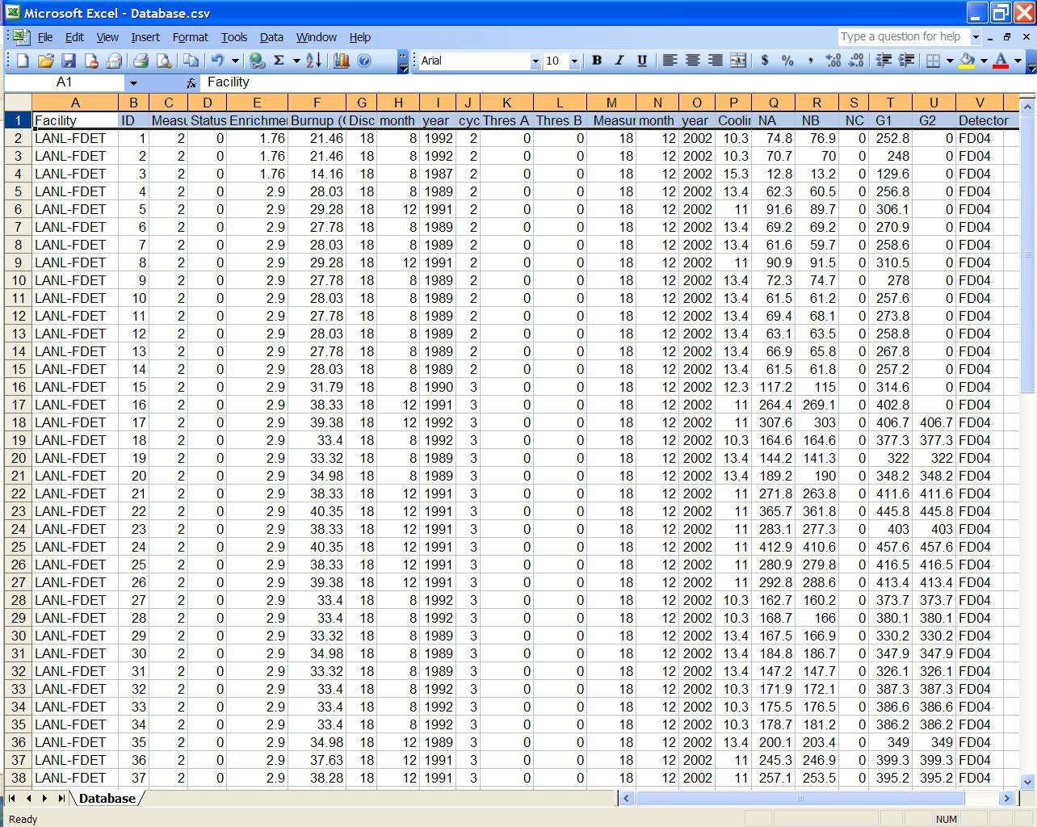**A data file opened with Excel is shown:

The information contained in each of the 22 columns is as follows:

| Col | Column Name | Data Type | Additional Information |
| --- | --- | --- | --- |
| 1 | Facility name | 32 ASCII characters (any combination) |  |
| 2 | Assembly ID | 32 ASCII characters (any combination) |  |
| 3 | Measurement type | 1 = cycle verification  2 = assembly verification | This signifies to the software the type of measurement/analysis to be performed on this assembly. |
| 4 | Measurement status | 0 = unmeasured  1 = suspect  2 = good  3 = neutral  5 = measured | The measurement status will be changed by the software after a measurement has been made on this item. The measurement status can be 0-9, but users need to know only that measurement status 0 is for an unmeasured assembly. A user can force the software to consider a given assembly as “measured” by making the measurement status 5. When the software is executed, this statuswill likely be changed by the software to a value greater than 0. The precise value is determined by a comparison to database entries in the DB file (discussed later). The measurement status is then used by the software to determine if a measurement should be labeled as “good”, “suspect”, or “neutral”. |
| 5 | Enrichment | Percentage | The declared initial 235U enrichment for each assembly. |
| 6 | Burnup | GWd/MT | The declared burnup for each assembly. |
| 7 | Discharge day | Integer | The declared day (date) of discharge. |
| 8 | Discharge month | Integer | The declared month of discharge. |
| 9 | Discharge year | Integer | The declared year of discharge. |
| 10 | Cycle number | Integer from 1 to 9 | The declared cycle number. |
| 11 | Thres A | Not used. | Not used. The threshold applied to neutron channel A. |
| 12 | Thres B | Not used. | Not used. The threshold applied to neutron channel B. |
| 13 | Measurement day | Integer | The day (date) of the month of each measurement. The software updates this column after each assembly is measured. |
| 14 | Measurement month | Integer | The month of each measurement. The software updates this column after each assembly is measured. |
| 15 | Measurement year | Integer | The year of each measurement. The software updates this column after each assembly is measured. |
| 16 | Cooling time | Positive real or float | The cooling time (years) for each measurement. This time can be either directly declared or is calculated and updated by the software after each measurement, based on a declared discharge date (columns 7-9). |
| 17 | NA | Positive real or float | The neutron count rate observed in GRAND pulse channel A. The software updates this column after each assembly is measured. |
| 18 | NB | Positive real or float | The neutron count rate observed in GRAND pulse channel B. The software updates this column after each assembly is measured. |
| 19 | NC | Positive real or float | The neutron count rate observed in GRAND pulse channel C. The software updates this column after each assembly is measured. |
| 20 | G1 | Positive real or float | The gamma dose observed in GRAND current channel 1. The software updates this column after each assembly is measured. |
| 21 | G2 | Positive real or float | The gamma dose observed in GRAND current channel 2. The software updates this column after each assembly is measured. |
| 22 | Detector | Alphanumeric string | The ID of the detector used in this measurement. The software updates this column after each assembly is measured. |

## Measurementplan (MP) File

The MP file contains a list of the items that an inspector may choose to measure. The default name is “Measurementplan.csv”, but inspectors may change the name to a name of their choice, using the “MEASUREMENTPLAN” parameter in the INI file. Based on assemblies selected for measurement at a facility, a measurement plan file is created. This is accomplished using Excel and an existing data (MP, M, or DB) file (a file that already contains the header line). If the chosen file contains data entries that are not applicable, they can easily be deleted. The information for each planned measurement must include:

* The facility name and assembly ID (columns 1 & 2)
* The type of measurement desired must be 1 for a cycle verification measurement and 2 for an assembly verification measurement (column 3)
* The measurement status (column 4) should be 0
* A declared enrichment and burnup (columns 5-6) must be entered for each assembly verification measurement. For cycle verification measurements, the enrichment and burnup can be left blank.
* For each assembly verification measurement, there must be either a declared discharge date (columns 7-9) or a declared cooling time (column 16) for each line in the MP file. If there is a declared cooling time, then this is used in the analysis. If no declared cooling time exists, then the declared discharge date is used in conjunction with the date obtained from the computer at the time of the measurement to calculate the cooling time
* For cycle verification measurements, there must be a declared assembly cycle number (column 10)
* The measurement date (columns 13-15) and measurement data fields (columns 17-21) should be empty, since the measurements haven’t been taken yet
* Threshold A and B (columns 11-12) are currently unused
* Detector ID (column 22) is left blank

Before measurements are taken, some fields are blank or zero. An example MP file is shown:

Facility,ID,Measurement type,Status,Enrichment (%),Burnup (GWd/MT),Discharge day,month,year,cycle #,Thres A, Thres B, Measurement day,month,year,Cooling Time (years), NA, NB, NC, G1, G2, Detector

LANL-FDET,1,2,0,1.76,21.46,18,8,1992,2,0,0, , , ,0,74.8,76.9,0,252.8,0,

LANL-FDET,2,2,0,1.76,21.46,18,8,1992,2,0,0, , , ,0,70.7,70,0,248,0,

LANL-FDET,3,2,0,1.76,14.16,18,8,1987,2,0,0, , , ,0,12.8,13.2,0,129.6,0,

LANL-FDET,4,2,0,2.9,28.03,18,8,1989,2,0,0, , , ,0,30.3,30.5,0,256.8,0,

After each assembly measurement, the MP file is updated with:

* The measured neutron count rates observed in the miniGRAND (or GRAND-3) pulse-counting channels A, B, and C (columns 17-19), however, only neutron channels A and B are used in the analysis
* The gamma doses observed in the current channels 1 and 2 (columns 20-21), however, only gamma channel 1 is used in the analysis
* The measurement date (columns 13-15)
* A non-zero measurement status parameter (column 4) of “good”, “suspect”, or “neutral”
* The specific detector ID used for the measurement (column 22)

## Database (DB) File

The default name is “Database.csv”, but inspectors may change the name to a name of their choice, using the “DATABASE” parameter in the INI file. A DB file must exist when the FDMS is executed. When assemblies listed in the MP file are selected and measured, these results are compared to all similar assemblies described in the DB file. If the new measurement is found to be consistent with the DB entries, then the measurement status for the new measurement is “good”. If a new measurement appears to be inconsistent with the corresponding entries in the DB file, then the new measurement is labeled “suspect”. If no entries in the DB file can be compared to the new measurement, then the new measurement status is set to “neutral”.

## Measurements (M) File

The M file name must have the file extension “csv”. The default name is “Measurements.csv”, but inspectors may change the name to a name of their choice, using the “MEASUREMENTS” parameter in the INI file. After each measurement, including background measurements, the M file is appended with the declarations, corresponding neutron count rates, and gamma doses from the last measurement. For the background measurements, the declaration fields are left blank. The M file does not have to exist at the time of execution. If it does exist, the new measurements will be appended to the bottom of the existing file. The M file is thus a log of all measurements in the order they were taken.

# The FDMS Application

## Starting FDMS

When accessing Unattended FDMS through the “Integrated Review Software” (IRS), click Start > All Programs > IRS > FDMS. Documentation for all installed IRS applications, including FDMS and RAD, is found under the “IRS Documentation” link on the same menu.

## Setting File Locations (Setup)

If the FDMS application cannot find/read the database, measurement plan, or measurement file, the inspector will be asked if he/she wants to find them manually. The database file example is as follows:

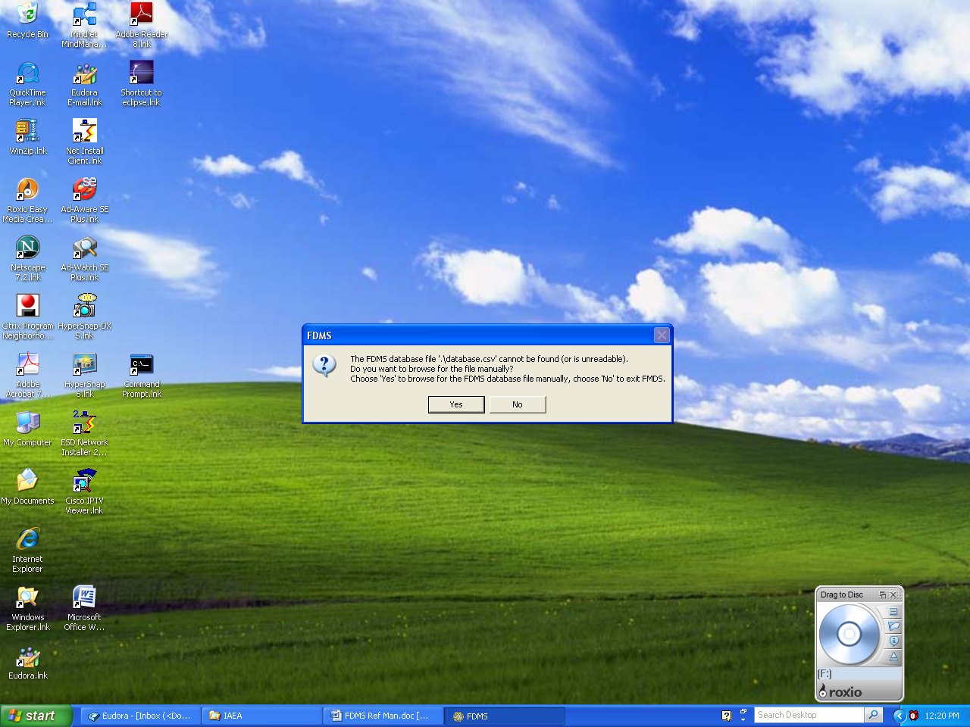

When the inspector chooses “Yes”, a browse window will prompt the inspector to enter the file location.

## Interface

When the FDMS application starts, the “FDMS – Measurement Type” window is displayed:

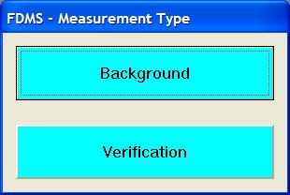

If “Background” is chosen, background measurements are taken (see § Background Measurements below). If “Verification” is chosen, then the “FDMS – Verify” window is displayed:

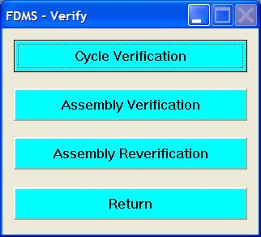

To verify the declared cycle of an assembly, choose “Cycle Verification” (see § Cycle Verification below). To measure and verify an assembly, choose “Assembly Verification” (see § Assembly Verification below). The “Assembly Reverification” button currently does nothing. To return to the “FDMS – Measurement Type” window, choose the “Return” button.

## Basic Attended FDMS Functions

### Background Measurements

When the “Background” button is selected in the “FDMS – Measurement Type” window, background measurements are taken, and then stored in the BACKGROUND section of the INI file.

The BGCYCLES INI file parameter determines the number of background measurement cycles performed. The BGCYCLETIME INI file parameter determines the wait time between measurement cycles. For example, if BGCYCLETIME=30 and BGCYCLES=3, then each background measurement will consistent of three 30-second measurements. There is essentially little difference between three 30-second measurements and a single cycle 90-second measurement. However, the gamma dose readings are updated on the computer screen only after every cycle. Therefore, if the users wish to see gamma readings while background measurements are in progress, then BGCYCLES will need to be set to greater than 1.

A background measurement can be aborted (see § Aborting an Incomplete Attended Measurement).

### Cycle Verification

In Cycle Verification, a plot of the neutron count rates v. the declared cycle number can be used to verify declared cycle numbers. When the “Cycle Verification” button is selected, the “Cycle Verification” window is displayed:

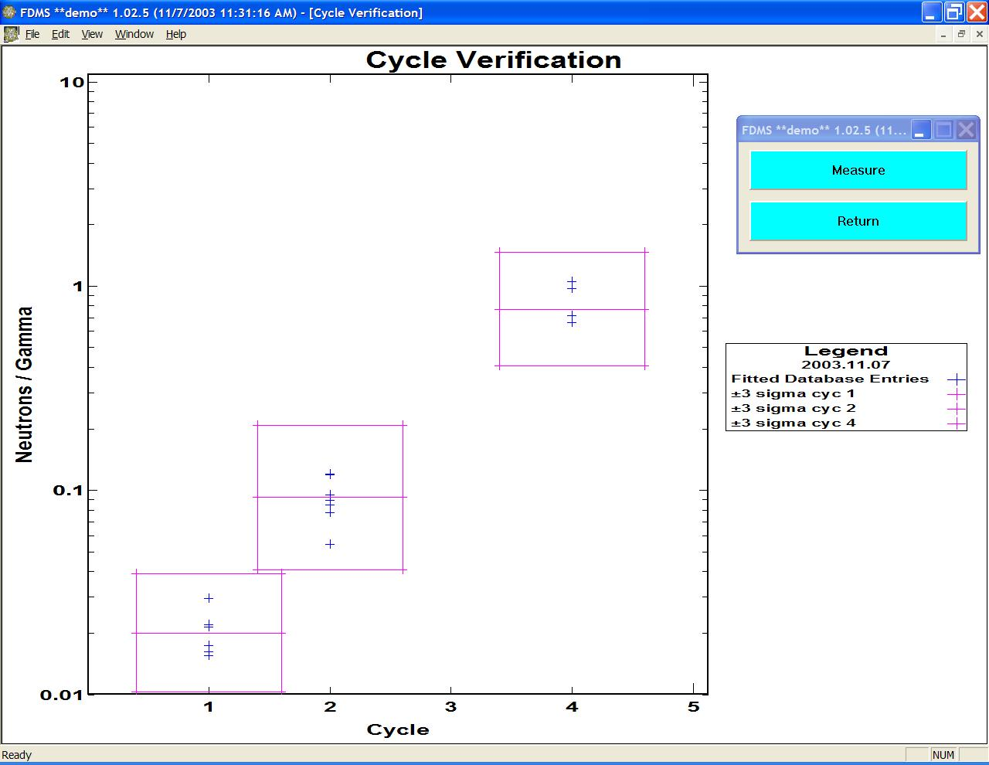

This window shows the plot of Neutrons/Gamma v. Cycle number for current database entries (from the DB file). The blue crosses show “fitted” database entries. The fitted database entries are the type-1 measurements from the DB file. In this case, “fitted” means there were enough measurements per cycle to enable both an average and standard deviation to be determined for the Neutron to Gamma ratio. Notice that in this case, the DB file did not contain any type-1 measurements with a declared cycle number of 3. The boxes show the 3-sigma limits for each of the cycle numbers with “fitted” database entries. Notice that the “FDMS – Measurement Type” window can be moved around the screen (in this example, to the top, right corner of the window).

### Normal Assay Measurement

To measure an assembly and compare it to the current database entries, select the “Measure” button. When this button is selected, the “New Measurement” window is displayed:

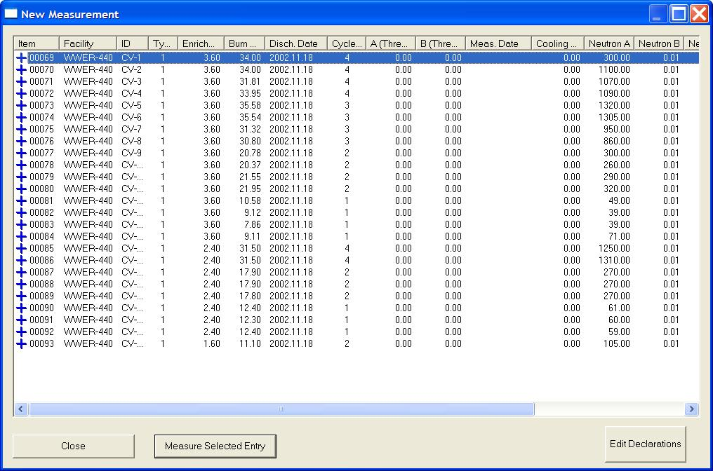

Notice that only type=1 (cycle verification) measurement plan (MP) file entries are shown. The icons on the left-hand side of the table, under the “Item” heading, signify the measurement status. The blue crosses signify that these items have not been measured. A measurement plan can be modified (add, remove, or edit) from this window (see § Modifying a Measurement Plan Entry).

To measure a given item, click on it and then click on the “Measure Selected Entry” button. For example, if the assembly with ID=“CV-1” is selected for measurement, then the “Normal Assay” window would look like:

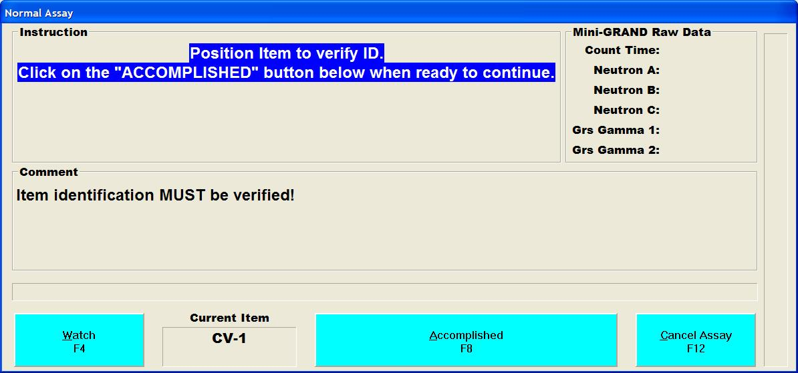

If the “Watch” button is selected, users will be able to watch, in detail, the communication with the instrument. The measurement can be aborted using the “Cancel Assay” button (see § Aborting an Incomplete Attended Measurement). Once the inspector has positioned the assembly to verify its ID, the “Accomplished” button should be pressed. The inspector will then be asked to verify the item ID of the assembly to be measured:

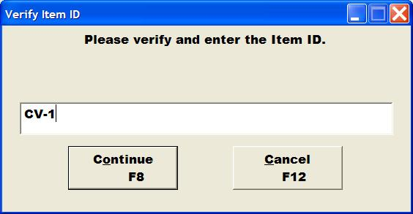

The “Cancel” button can be selected to cancel the cycle verification measurement and return to the “New Measurement” window. Once the ID has been entered and the “Continue” button has been pressed, the “Normal Assay” window changes as shown:

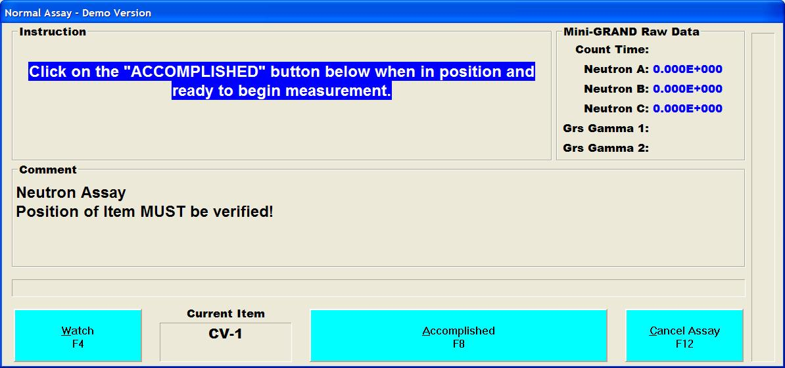

Again, the measurement can be aborted using the “Cancel Assay” button (see [above](#Canc)). Once the instrument is in the required measurement position, then the “Accomplished” button should be activated.

The CYCLES INI file parameter determines the number of measurement cycles performed. The CYCLETIME INI file parameter determines the wait time between measurement cycles. For example, if CYCLETIME=20 and CYCLES=3, then each measurement will consist of three 20-second measurements. There is essentially little difference between three 20-second measurements and a single cycle 60-second measurement. However, the gamma dose readings are updated on the computer screen only after every cycle. Therefore, if the users wish to see gamma readings while measurements are in progress, then CYCLES will need to be set to greater than 1.

After the measurement is complete, the “Normal Assay” window closes and the “Background Corrected Results” window is displayed:

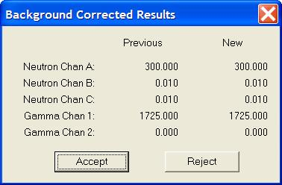

If this item has been previously measured (as found in the MP file), non-zero data will appear in the “Previous” column. The new instrument measurement is displayed in the “New” column. If the inspector determines that the new measurement is not valid, the “Reject” button is clicked, the new measurement is discarded, and the “New Measurements” window is reopened with no changes. The inspector may wish to troubleshoot why the measurement was invalid or retake the measurement.

If the inspector decides that the measurement is valid, he/she clicks the “Accept” button, the new measurement is accepted (updated in the MP file and appended to M file), and the “New Measurements” window reopens with updated information:

* the measurement date is set to the current date,
* the measurements just taken are recorded, and
* the new measurement status is displayed.

If the new measurement is found to be consistent with the DB entries, then the measurement status for the new measurement is “good” (green). If a new measurement appears to be inconsistent with the corresponding entries in the DB file, then the new measurement is labeled “suspect” (red). If no entries in the DB file are found to compare to the new measurement, then the new measurement status is set to “neutral” (orange). The measurement status color is used in both the “New Measurements” window and on the Cycle Verification plot.

In the example below, if CV-2, CV-3, CV-5, CV-9, and CV-12 are also selected and measured and these measurements are accepted, then the “New Measurement” window will be displayed, as shown:

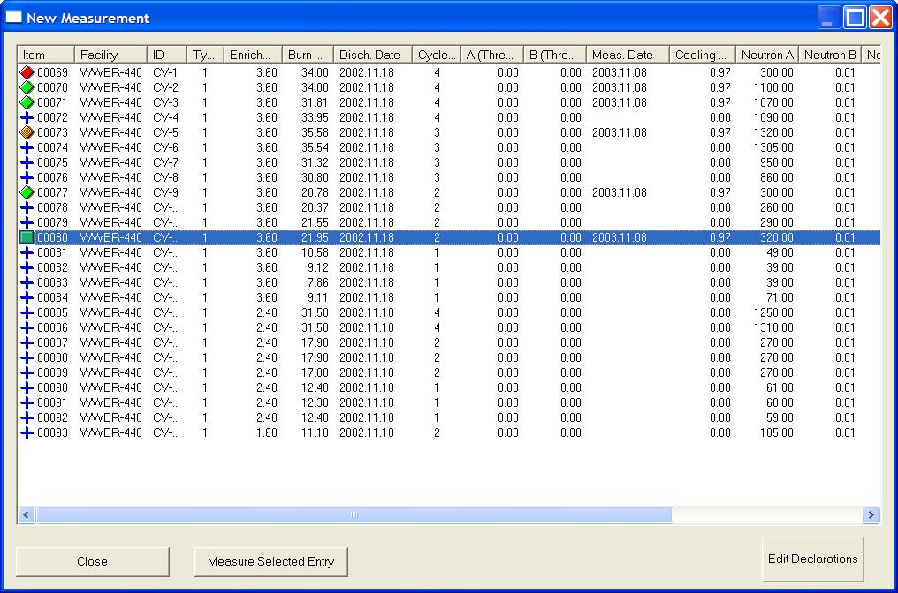

Notice that six entries now have icons that signify a measurement status other than the original blue crosses. A square is used to signify the most recent measurement. If the most recent measurement is “neutral”, then it is signified by a black square (instead of orange).

### Plot New Measurement Data

When “Close” is selected in the “New Measurement” window, the corresponding Neutrons/Gamma v. cycle plot is displayed:

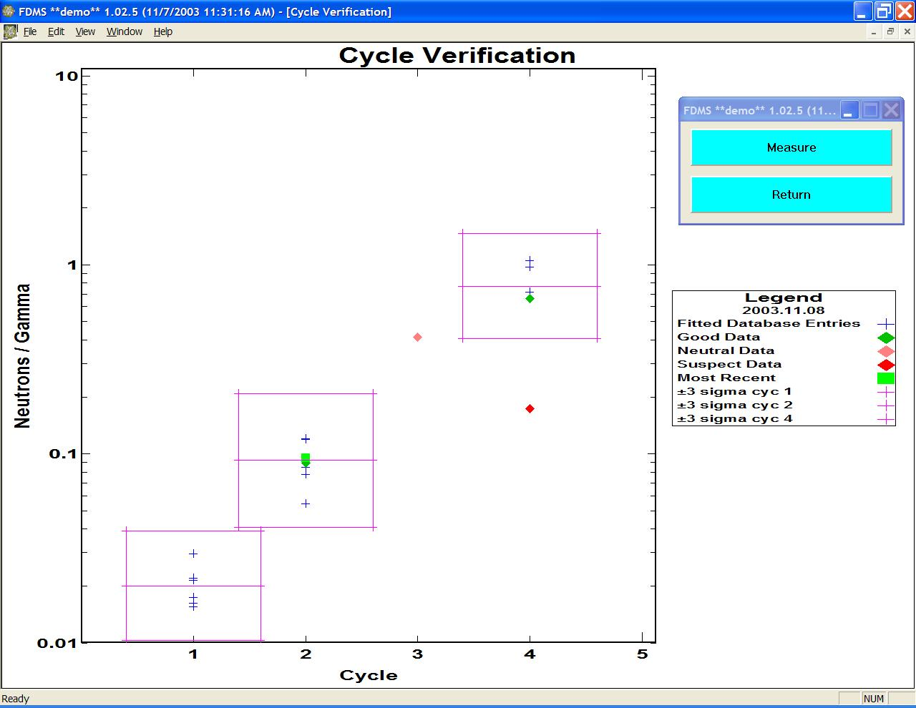

If the “Return” button in the “FDMS - Cycle Verification” window is pressed, then the inspector is returned to the “FDMS – Verify” window (see [above](#Ver)). The “Measure” button can be used to continue with more Cycle Verification measurements.

### Assembly Verification

In Assembly Verification, assembly measurements are taken and inspectors use three types of plots to help verify that an assembly is consistent with facility-declared values.

When the “Assembly Verification” button is clicked from the “FDMS – Verify” window (see § [above](#Ver)), the “FDMS – Assembly Verification” window is opened, as shown:

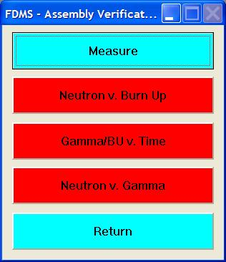

The inspector can now analyze new measurements, using any/all of the following three plot options:

* “Neutron v. Burn Up” - decay corrected neutrons v. declared burnup,
* “Gamma/BU v. Time” - gamma divided by declared burnup v. declared cooling time, and
* “Neutron v. Gamma” - decay-corrected neutrons v. decay-corrected gammas).

All plot options are initially turned off and displayed with red buttons. If the Neutron v. Burn up option is selected, then the corresponding button turns green and the “Time Corrected Neutron v. Burn Up” window is displayed, as shown:

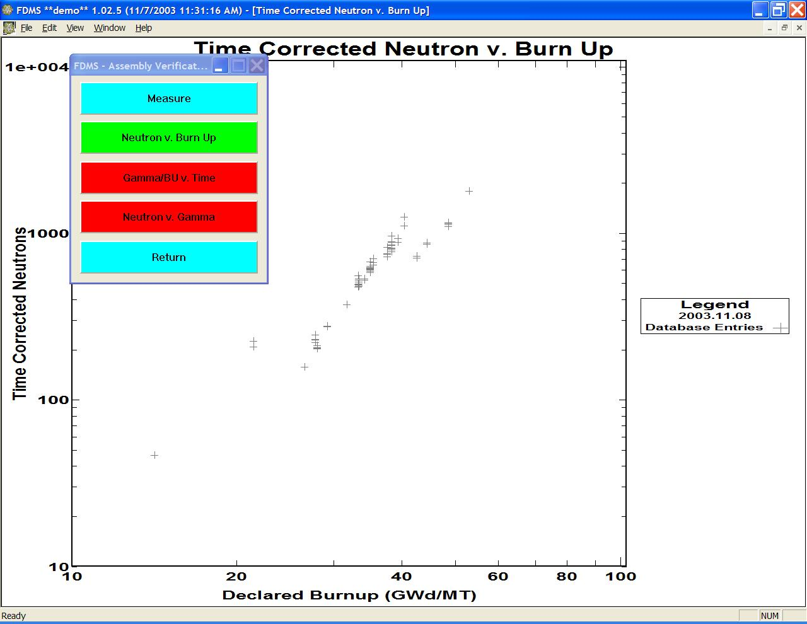

The displayed data points are all of the type=2 (assembly verification) entries from the database (DB) file.

When the “Measure” button is selected, the “Assembly Verification Measurements” window is displayed, showing all type 2 entries from the measurement plan (MP) file. Assembly Verification measurements are taken exactly the same way as Cycle Verification measurements (see § Cycle Verification) with the following differences:

* The window name is “Assembly Verification Measurements” instead of “New Measurement”
* Only type 2 (assembly verification) measurement plan (MP) file entries are displayed instead of type 1 (cycle verification) entries

Although measurements are performed the same way, the analysis performed is different.

An example of a Neutron v. Burn Up plot after several measurements is shown:

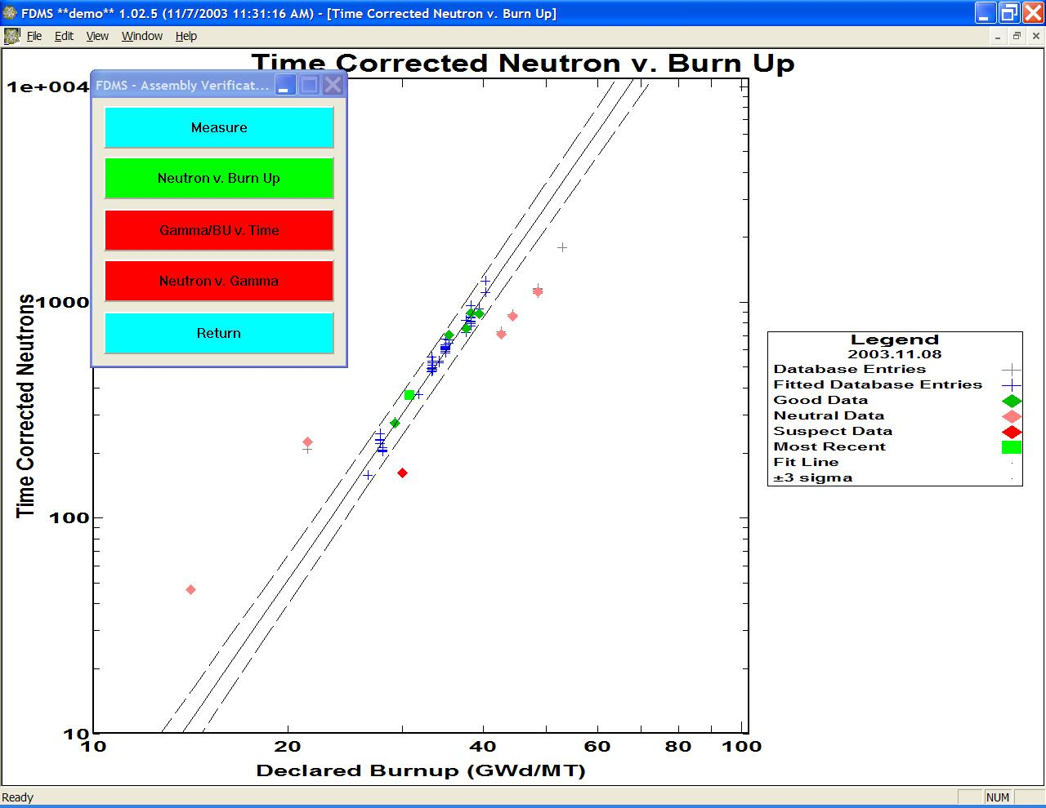

Notice that eight classes of objects are displayed in the plot (see the legend). The most recent measurement is shown by the square at a Burn Up of ~30 GWd/MT and a Time Corrected Neutrons of ~300 (1/s). In this case, the most recent measurement was of an assembly with an initial 235U enrichment of 2.9%, where the DELTA\_ENRICHMENT parameter was set to 0.15%. The “fitted” database entries are those with enrichments from 2.75% to 3.05%. The database entries with enrichments beyond this range are displayed with gray crosses. The measurements of assemblies with enrichments in the 2.75% to 3.05% range are assigned the labels “good” or “suspect” by comparing them to the fit made to the “fitted” database entries. The solid line shows a standard linear regression fit, while the dashed lines show the corresponding 3-sigma confidence limits. The measurements that lie inside the 3-sigma limits are “good” and are displayed in green. The measurements outside these limits are “suspect” and are displayed in red. Measurement on assemblies with enrichments more than DELTA\_ENRICHMENT from the enrichment of the most recently measured assembly are assigned the label “neutral” and are plotted in orange. The “neutral” points in the above plot are derived from measuring assemblies with an enrichment of 1.78%, and a second set of points is derived from measuring assemblies with enrichments of 3.72% and 3.87%.

If the next set of points is derived from another assembly with an enrichment of 1.78%, then the generated Neutron v. Burn Up plot is shown:

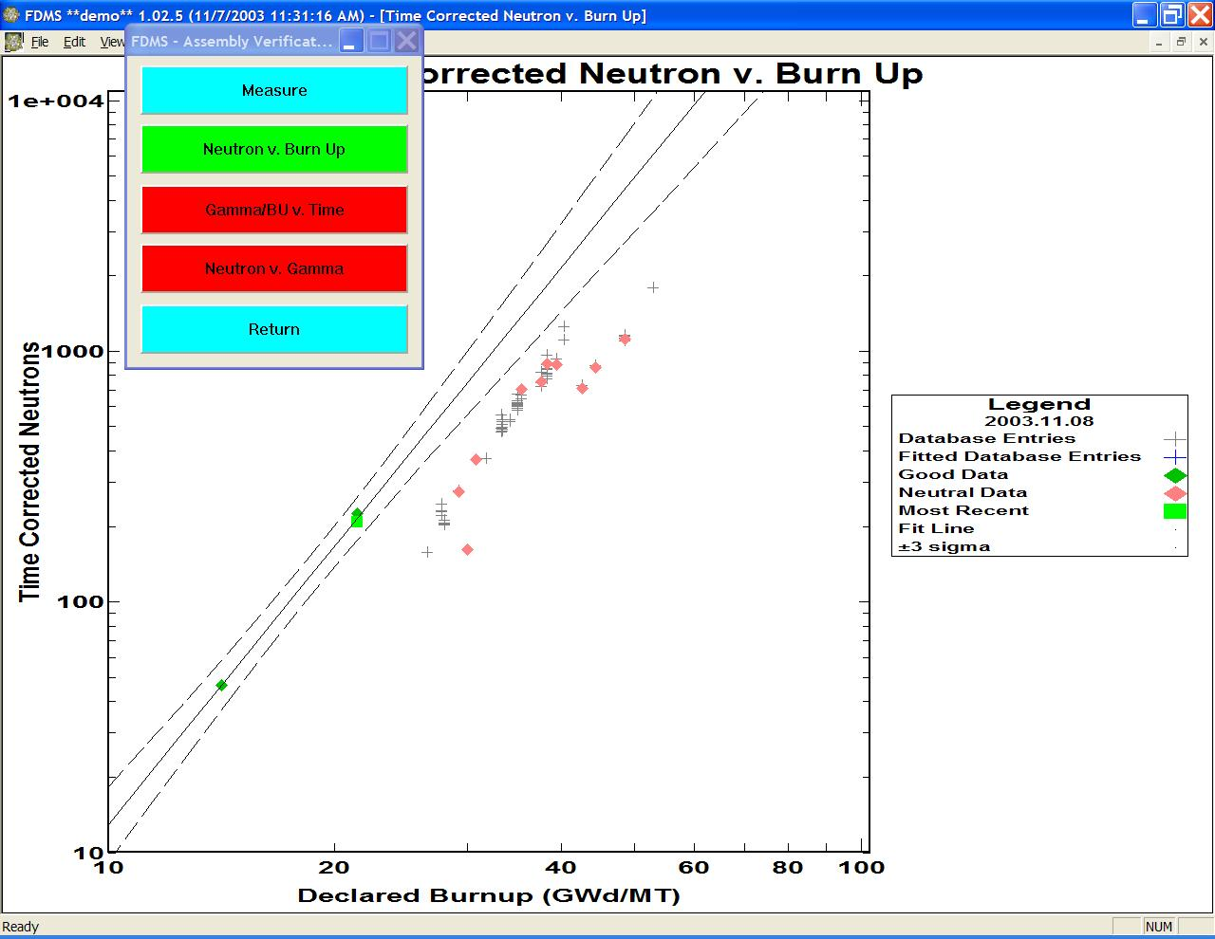

This new most recent point is compared to the DB entries with enrichments that are within 0.15% of 1.78%. The most recent measurement is the left-of-center point, has been assigned the status “good”, and is displayed by a green square. What was previously the “neutral” point at a burnup of ~21 GWd/MT has an enrichment value within 0.15% of 1.78% and can thus be compared to the new fitted database entries. Its status has been changed from “neutral” to “good”. The other measurements were of assemblies with enrichments of ~2.9%. These measurements cannot be compared to the new fitted database entries and are thus assigned the status “neutral”.

An example of a Gamma/Burnup v. Cooling Time plot is shown:

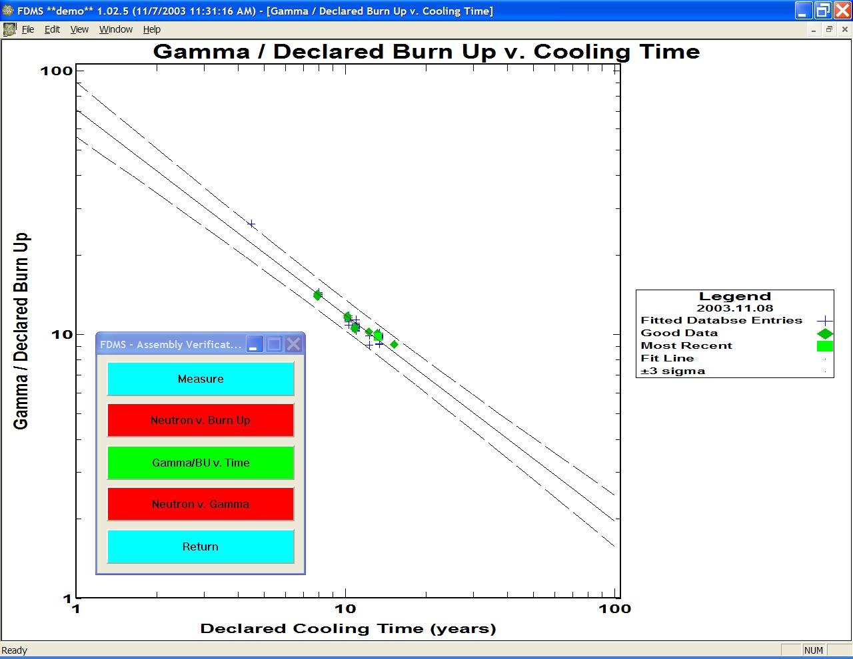

This type of test is relatively insensitive to the assembly enrichments; thus, all database entries can be simultaneously fitted, without reference to the enrichment.

An example of a Neutron v. Gamma plot is shown:

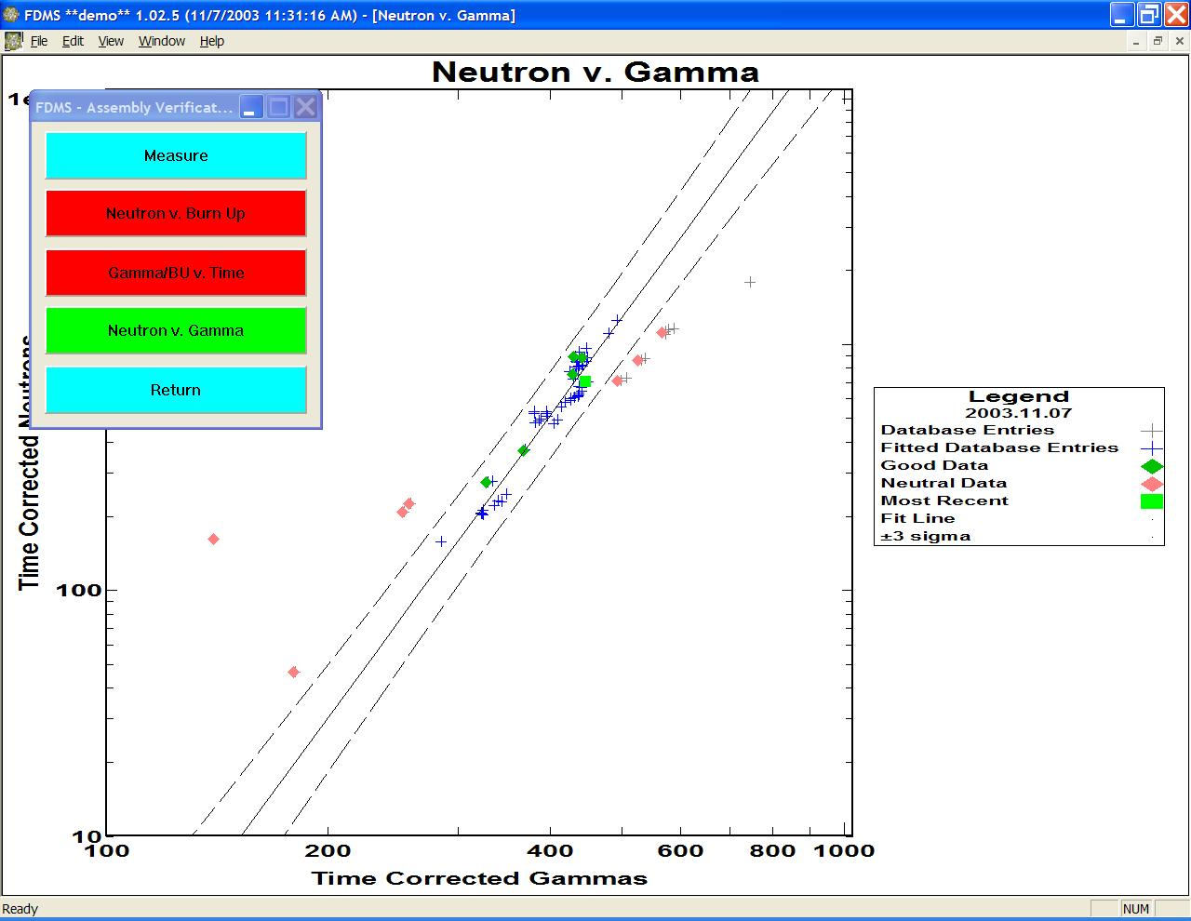

This type of test is sensitive to the assembly enrichment and, despite time corrections to both the neutron and gamma data, is also very sensitive to the cooling time. However, it is possible that for assemblies with similar enrichments and the same cooling times, this test may meet the requirements for a partial defect measurement. In the example shown above, the parameters DELTA\_ENRICHMENT and DELTA\_COOLING time were set to 0.15% and 0.2 years, respectively. The large number of “neutral” points occurs because many of the previous measurements have (in this case) either enrichments greater than 0.15% away from that of the most recent assembly or a cooling time greater than 0.2 years different from that of the most recent assembly. However, the 3-sigma limits for this test are significantly narrower than in the other two tests.

The user may choose to turn on any combination of the assembly verification tests. With more than one of the tests on, measurement points are assigned the status “good” only if the measurement points pass all “on” tests. The status “suspect” is assigned to a measurement point if it fails a single “on” test. If a point is labeled “neutral” in any of the “on” tests, then it will be “neutral” in all tests.

Anomalous results can be associated with small DB files. For example, if only one or two DB entries can be compared to the “most recent” measurement, then strange results may be obtained. Data sets containing less than three points introduce problems in getting linear fits with confidence limits. Currently, users should avoid cases where new measurements will be compared to less than three DB entries. If this comparison is done, the user should ignore the strange plot(s) and move on to the next measurement. This problem will be fixed.

## Advanced Attended FDMS Functions

### Modifying a Measurement Plan Entry

The measurement (“New Measurement” or “Assembly Verification Measurements”) dialog allows a measurement plan entry to be edited from within the FDMS application. New entries can be created, entries may be deleted, and a small subset of information for an existing entry may be changed. Table 1 below summarizes the six editable pieces of information per entry, with associated constraints on their values.

**Summary of Six Editable Pieces of Information**

|  |  |  |  |  |
| --- | --- | --- | --- | --- |
| **Name** | **Type or unitary value** | **Low range** | **High range** | **Example** |
| ***Facility*** | Alphanumeric | Empty | 32 characters | X22-F; Unit H |
| ***Assembly ID*** | Alphanumeric | Empty | 32 characters | 77B-1:30 |
| ***Enrichment %*** | % | 0.0 | 100.0 | 3.28 |
| ***Burnup*** | GWd/MT | 0.0 | 100.0 | 31.08 |
| ***Discharge Date*** | Year, month, day | January 1, 1950 | February 18, 2038 | 2003.11.07 |
| ***Cycle Number*** | Single digit | 1 | 10 | 3 |

Table 1

These operations are available by selecting the “Edit Declarations” button on the measurement dialog, as shown:

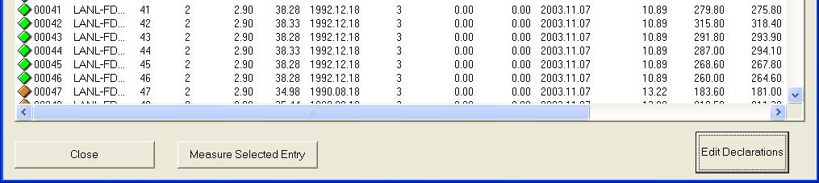

The “Edit Selected Entry”, “Add New Entry”, and Remove Selected Entry” buttons appear:

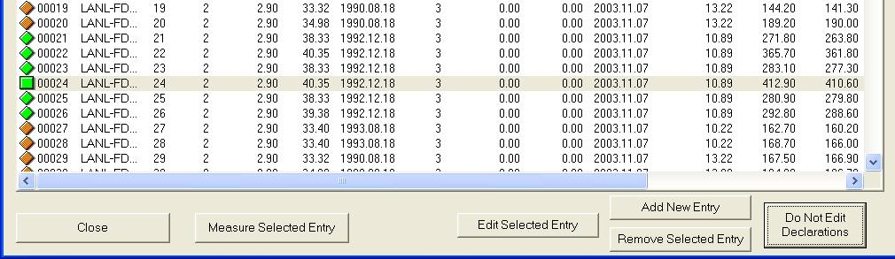

### Add New Entry

To add a new entry, select a row to use as a source for data and then press “Add New Entry”. A new row for the new entry is inserted into the list, and a dialog appears with six fields that can be edited for the new row. Useful data from the source entry will be copied to the new entry for the users’ convenience. Values that must be measured or computed will initially be set to 0. A default unique Item ID is created for the new entry. The user will then edit the six data items for the new entry with the “Editing new entry” dialog:

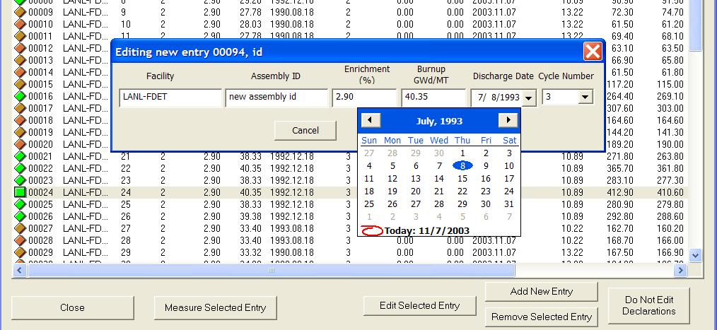

The example above shows an assembly ID already entered by the user (‘new assembly id’), and the Discharge Date calendar tool active, with a new Discharge Date chosen for this entry.

Each field will constrain the users’ entry to values that are allowed. Below is an example of an error message that can occur when a range for “Burnup” is exceeded. Clicking “OK” to a range entry warning reverts the offending value back to the previous acceptable value.

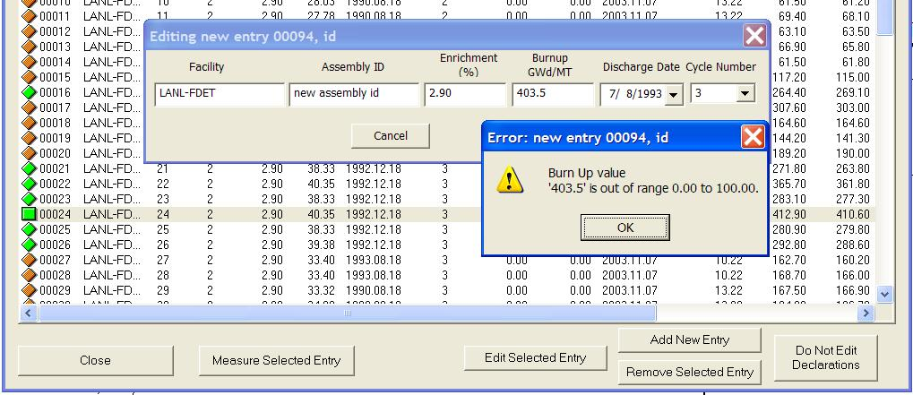

To discard the new entry, click “Cancel”. To save changes, click “OK” and a confirmation dialog will be presented:

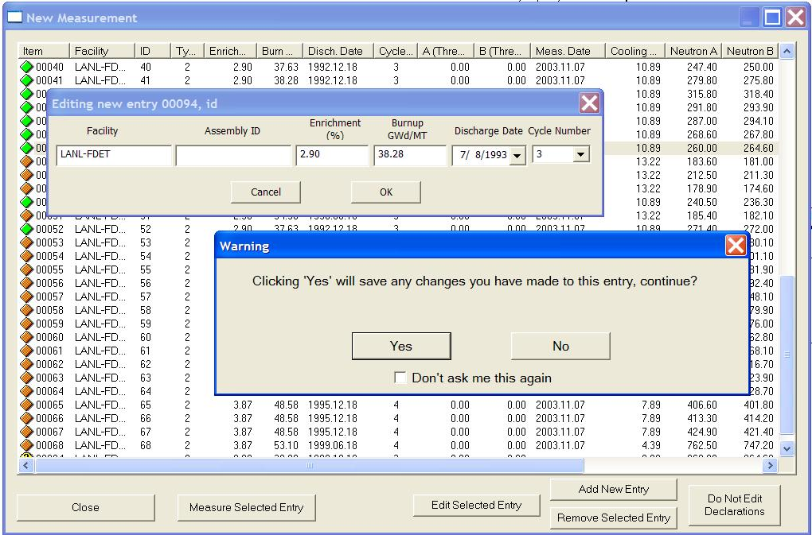

If “No” is selected, control is returned to the “Editing new entry” dialog. By choosing “Yes”, the new measurement plan entry is saved to the MP file and is included in the measurement display.

On the confirmation dialog box, the inspector may select the “Don’t ask me this again” checkbox:

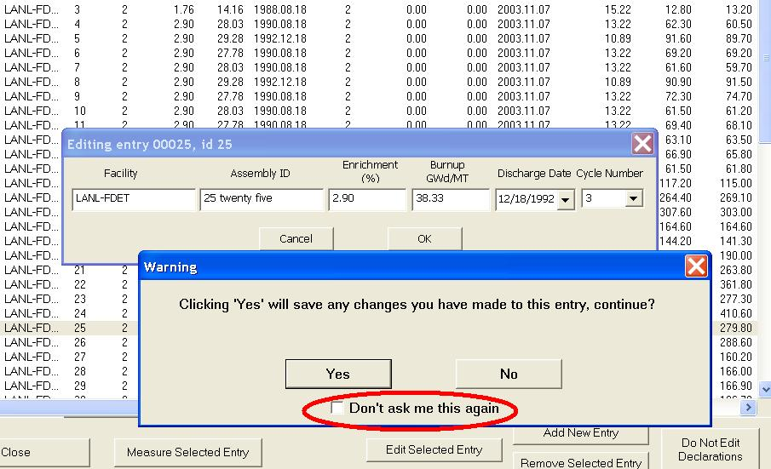

Checking this box will avoid displaying the confirmation dialog for each change made, thus streamlining extensive edit sessions. The confirmation dialogs can be restored by selecting “Reset Acks” from the main FDMS Edit menu.

### Remove Selected Entry

To remove an entry from the MP file, select a row to remove and then press “Remove Selected Entry”. A confirmation dialog is presented:

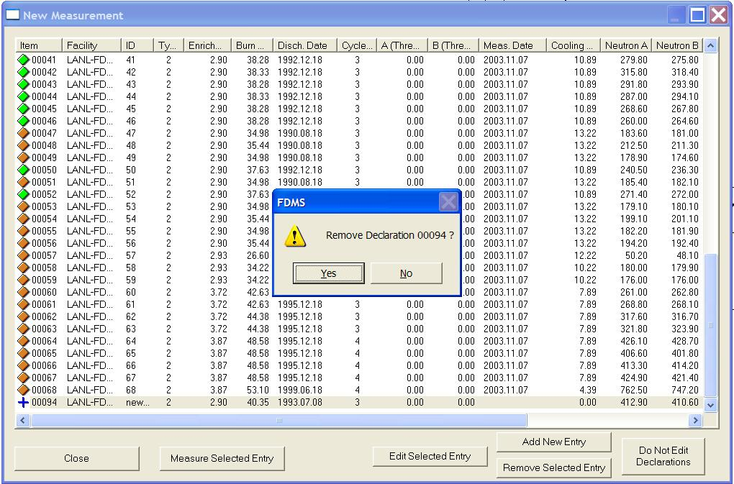

Click “Yes” to delete the entry from the measurement plan file and the measurement window (clicking “No” will not remove the entry).

### Edit Selected Entry

To edit an existing entry, select the entry to edit, press “Edit Selected Entry”, and modify the appropriate field(s):

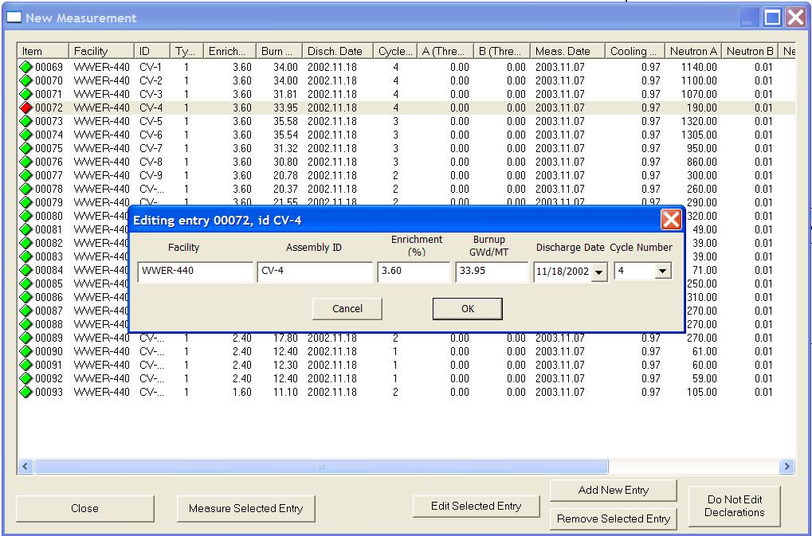

The “Editing entry…” dialog is presented and values then can be modified and saved. Refer to the § Add New Entry for how to enter field data and how to turn off (and restore) the confirmation dialog.

### Aborting an Incomplete Attended Measurement

After selecting to measure a background, cycle, or assembly measurement, it may be terminated early by selecting the “Cancel Assay” button.

If FDMS has not started a measurement cycle yet (see the background assay example below), there will be no data available. The “Abort Assay” dialog will ask “Are you sure you want to stop or cancel this assay?”. Two choices are presented:

* + Stopping the measurement by selecting the “STOP” button.
  + Continuing with the measurement by selecting the “NO” button.

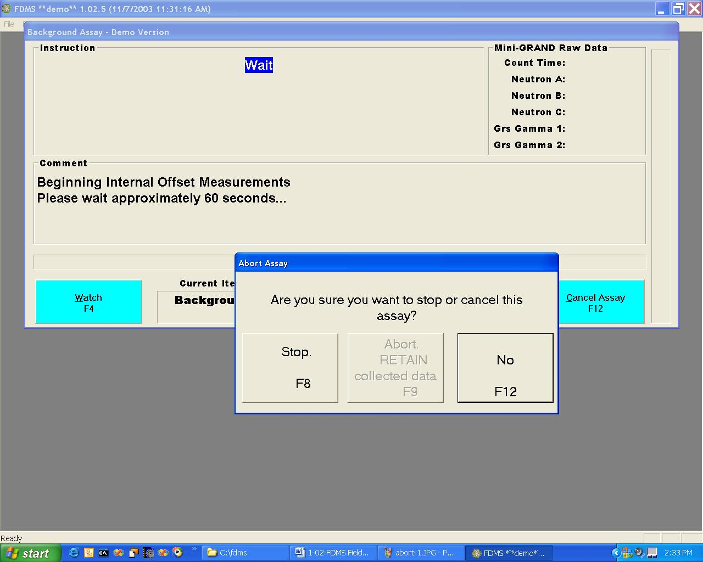

If the measurement cycle has already started, but has not completed (see the example below), the “Abort Assay” dialog will present three choices:

* + Stopping the measurement and discarding any data collected by selecting the “Abort, DISCARD any results” button.
  + Stopping the measurement at the end of the current cycle and preserving the collected data as the measurement results by selecting the “Abort, RETAIN collected data” button.
  + Continuing with the measurement by selecting the “NO” button.

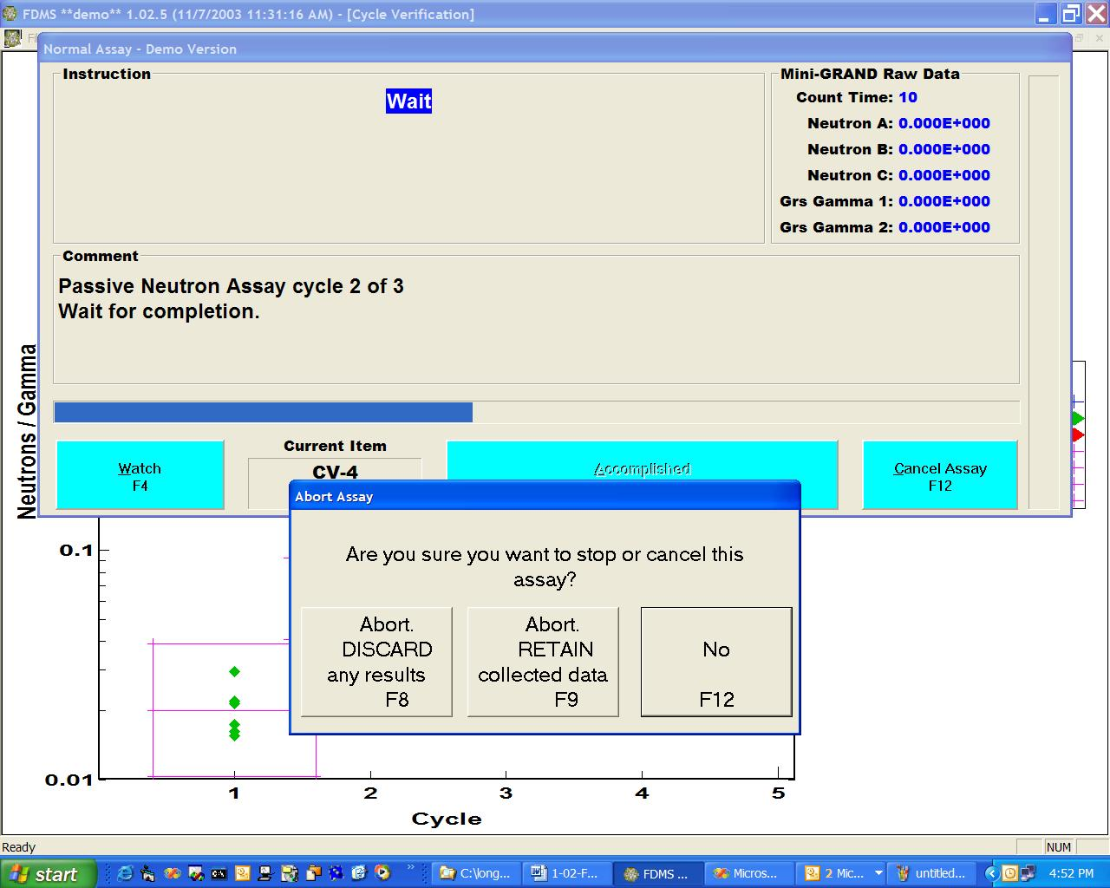

### Analysis of New Measurements with No Previous Measurements

The FDMS standard analysis mode is as follows: new measurements of assemblies declared in the MP file are compared to previous measurements of similar assemblies from the same or a similar facility, measured by the same or similarly calibrated fork detector, and stored in the DB file. However, if no previous measurements exist, then a self-consistency check can be performed by comparing new measurements to themselves. To do this, first remove any unmeasured items from the MP file and save a new version of the MP file containing only measured items. This process creates a DB file that matches the MP file. These changes and file creations can be performed using Excel. When saving new \*.csv files, remember to answer “yes” when the following statement appears: “to keep this format, which leaves out incompatible features, click yes”. After the MP file has been edited and the new DB file created, execute the demo version of the FDMS software. In this way, users can force the software to reread the new measurement results from the MP file and then force the software to compare these measurements to themselves. The DB file should contain only “good” data; thus, any obviously questionable data should be removed from the DB file. We have applied this procedure to the data displayed in the plots in the last section. The lowest point with a cycle number of 4 was removed from the “created DB file” because it is certainly inconsistent with the other cycle 4 measurements.

The generated Cycle Verification plot is shown in Figure 1.

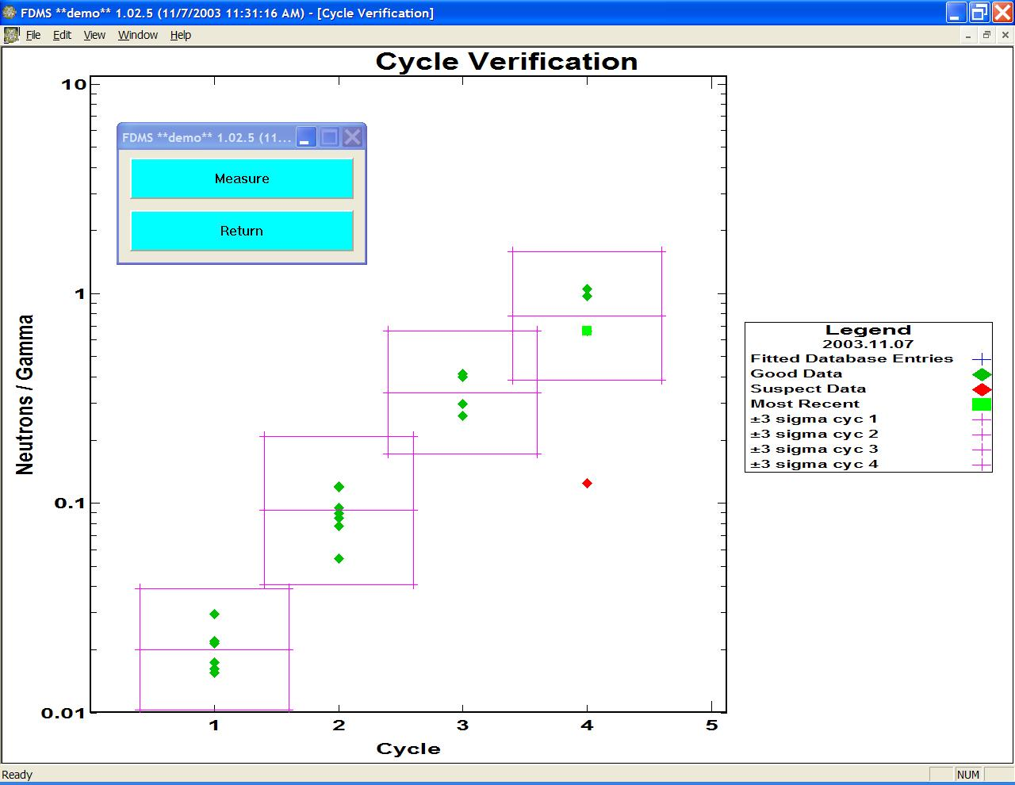

**Figure 1. Cycle Verification Plot**

The Gamma/Declared Burn Up v. Cooling Time plot is generated without the need to make any fake measurements with the software because the Gamma/Burn Up v. Cooling Time test is performed without reference to the assembly enrichment. This plot of the discussed data set is shown in Figure 2.

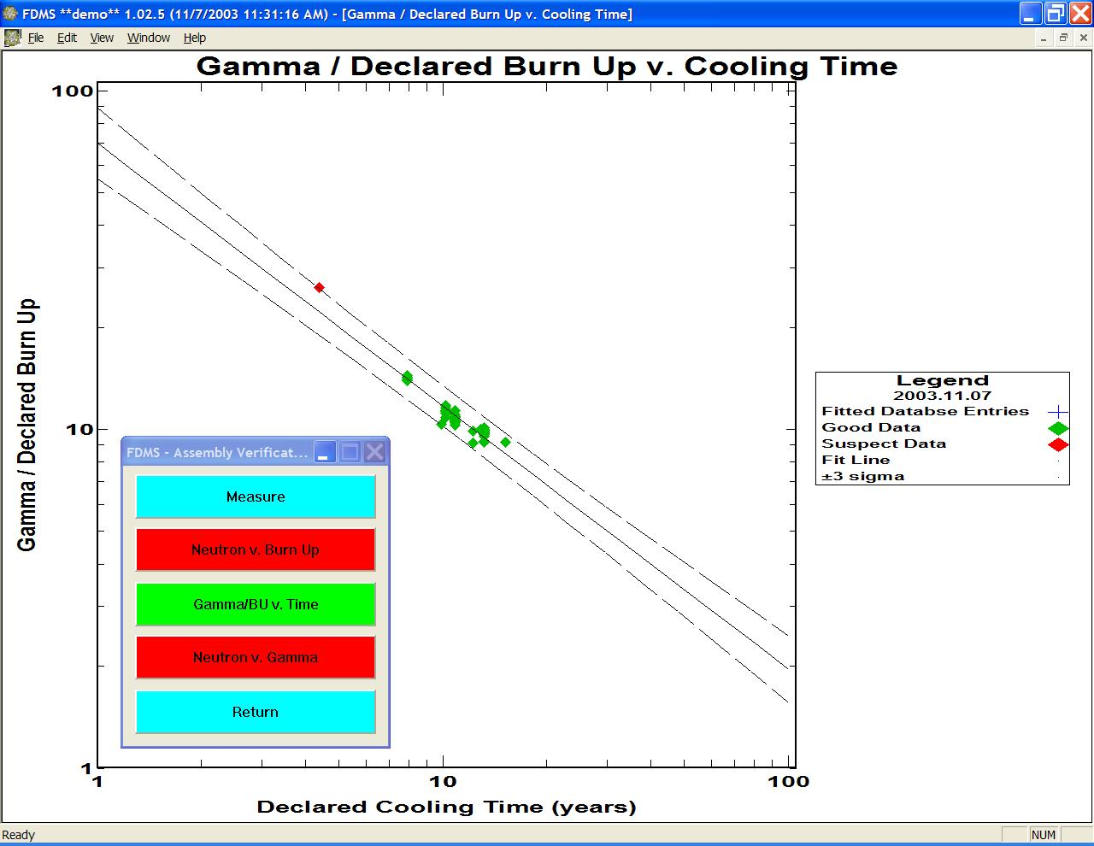

**Figure 2. Plot of the Discussed Data Set**

The Neutron v. Burn Up and Neutron v. Gamma plots require a most recent point before the software can determine which measurements in the DB file are to be compared to the measurements in the MP file. Remember that making fake (demonstration/training) measurements with the demo software will not change the measured data in the MP file. To generate the plot shown in Figure 3, a 2.9% assembly was chosen from the MP file and measured. Notice that one of the other 2.9% assembly measurements has been labeled “suspect” and is displayed by a red diamond. The measurements of the ~1.8% and ~3.8% enriched assemblies have been labeled “neutral” and are displayed on both sides of the 2.9% enrichment measurements.

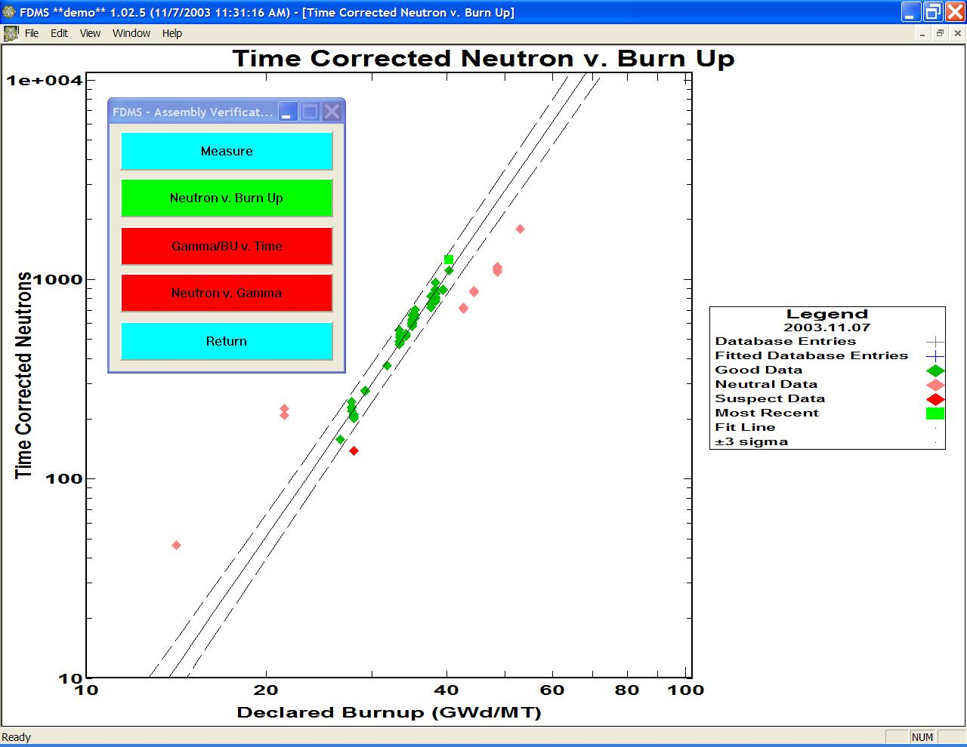

**Figure 3. Generated Neutron v. Burn Up and Neutron v. Gamma Plot for a 2.9% Assembly**

To analyze the measurements of the ~3.8% enriched assemblies, a demo measurement of one of the ~3.8% enriched items must be made. If this measurement is made, then the generated plot is displayed, as shown in Figure 4.

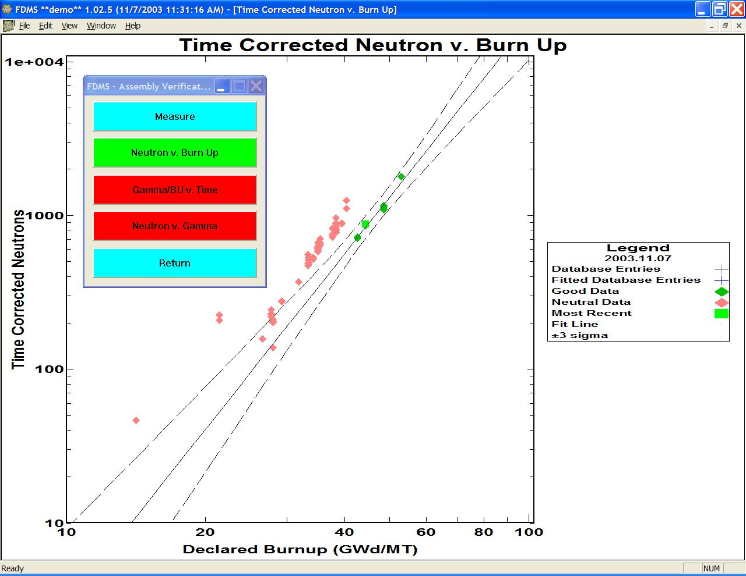

**Figure 4. Generated Plot of a Demo Measurement of an ~3.8% Enriched Item**

All of these ~3.8% enriched measurements have been labeled “good”. Notice that the ~1.8% and ~2.9% enriched measurements are now the “neutral” points.

An example Neutron v. Gamma plot is shown in Figure 5.

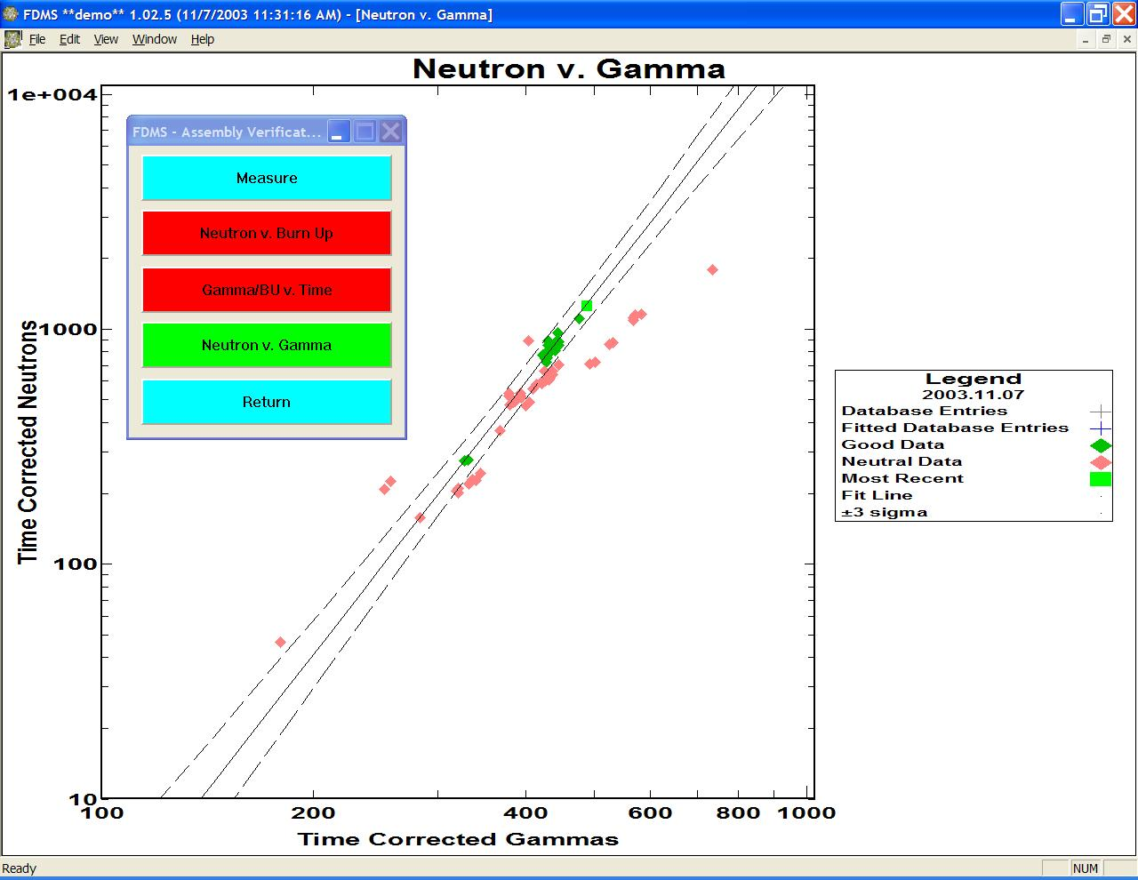

**Figure 5. Example Neutron v. Gamma Plot**

Remember that the Neutron v. Gamma test requires points with enrichments and cooling times close to the corresponding values of the most recent measurement. In the example shown above, the parameters DELTA\_ENRICHMENT and DELTA\_COOLING time were set to 0.15% and 0.2 years, respectively. The large number of “neutral” points is used because many of the measurements have (in this case) either enrichments greater than 0.15% away from that of the most recent assembly or cooling time greater than 0.2 years different from that of the most recent assembly. Wider ranges of enrichments and cooling times will produce a broadening of the 3-sigma limits and will weaken this test. Without research into more complex time and enrichment corrections, the Neutron v. Gamma plots are likely to meet the requirements for a partial defect test only if this analysis technique is limited to assemblies discharged at the same core refueling (i.e., very similar discharge dates) and with similar enrichments.

## Basic Unattended FDMS Functions

FDMS was also added to the Integrated Review Software (IRS) Suite to enable analysis of data collected by unattended monitoring systems. The Radiation Review (RAD) portion of the IRS suite identifies events in unattended data and exports those events for use by FDMS.

Once FDMS and RAD are successfully installed, both tools are available from the “Start” menu under “Integrated Review Software”. Documentation for all installed IRS applications, including RAD, is found under the “IRS Documentation” link on the same menu.

RAD is used to prepare unattended measurement data for use in FDMS:

1. The raw unattended measurement data are imported into RAD.
2. The data are reviewed graphically and numerically.
3. Events of interest are then determined using RAD event detection features, such as “Find Channel Events”.
4. Identified events are edited with identifying information,
5. Background events are added using the “Create Event” feature of RAD.
6. Finally, the identified events of interest are exported in order to be imported by FDMS for analysis.

FDMS imports the events in a three-step process, taking Background events first, analyzing new events second, and finally analyzing measurement that match existing measurement in FDMS. Each step of the import process in FDMS requires some event details to be added for each imported event to complete the analysis of the data. A tabular dialog style is used to display the event data and to allow editing and modifications of the data during import processing.

## Importing Events from Radiation Review

Unattended measurement data have been prepared for analysis in FDMS using RAD. Start FDMS from the same menu used to start RAD. FDMS looks similar to Figure 6 when started.

The FDMS integration has added the toolbar seen below the menu and the “Tools” menu. The toolbar controls and the “Tools” menu items fulfill the same function. All integrated tools can be started from the “Tools” menu (see Figure 7) or from the dropdown list on the tool bar (see Figure 8). If exported data are available to be imported into FDMS, a menu item “Import Measurements …” is present and enabled on the “Tools” menu (see Figure 7). Similarly, the last button on the tool bar will be enabled if exported data are available(see Figure 9)**.** The toolbar button is convenient for starting the FDMS data import processing. Selecting “Import Measurements …” or pressing the toolbar button starts the FDMS import processing.

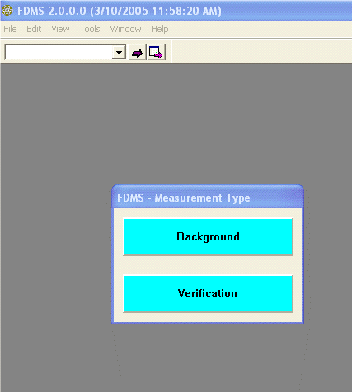

**Figure 6. FDMS**

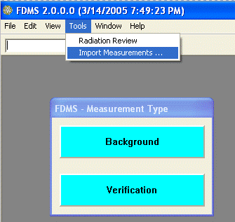

**Figure 7. The FDMS “Tools” Menu Item**

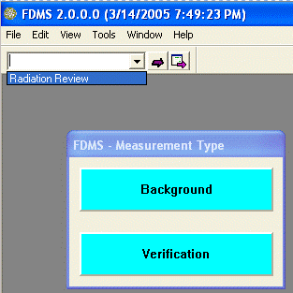

**Figure 8. The FDMS Toolbar IRS Tools Pulldown Menu**

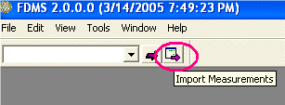

**Figure 9. The FDMS Toolbar “Import Measurements” Button**

The FDMS import process uses three sequenced steps to import, analyze, and retain events in FDMS.

1. Background measurements presented in a table dialog. Each event is represented by an arrow. Columns represent the various relevant data fields for a background measurement. The background measurements are processed and retained by user actions with the table dialog. Then …
2. New measurements are presented in a table dialog. A new measurement, one not found in the FDMS database, must be completely specified, successfully analyzed, and then accepted before it is saved by FDMS. The user edits the relevant data fields, affirmatively analyzes selected events, and finally accepts one or more successfully analyzed events. Visual indicators are used to flag missing data. Then …
3. Existing measurements that will be updated are presented in a third dialog. These events are selected, analyzed, and finally accepted into FDMS in the same manner as “Background” and “New Measurements”. The same visual indicators used in New Measurements analysis are used in the Existing Measurements table dialog.

Background events require little intervention; they are simply selected and analyzed. New events and events that are replacing existing measurements in FDMS require the completion of up to seven data items before a successful analysis can occur.

### FDMS Import Measurement Dialog Details

When the import processing is complete, the FDMS graphs can be used to evaluate the imported measurements for safeguards analysis.

Several affirmative user actions are required to analyze an imported event.

1. A checkbox is provided with each event row. The checkbox must be selected to analyze an event. Deselecting an event checkbox will cause FDMS to skip the analysis of the event.
2. Selected events are analyzed by pressing the “Analyze Selected Events” button.
3. The “Accept Measurements” button is selected to retain the analyzed events in the FDMS database. Only those events that are selected and have been successfully analyzed will be saved using the “Accept Measurements’ button.
4. The “Close“’ button will close the Background and the New and Existing Measurements dialogs, and no events from that table dialog will be saved in FDMS.

**Visual Status Indicators**

To support identification of required data values and display the status of ongoing event analysis, color text highlights and table row and cell background colors are used in the table dialogs as indicators (see Table 2).

**Table 2. Table of Colors Used as Indicators**

|  |  |
| --- | --- |
| Informational data | Immutable fixed data values (those values that cannot be changed) are displayed in basic black text with white background. |
| Required data | Data values that must be changed or initially specified by the user before a successful analysis can occur are displayed with a blue background. |
| Required data not specified or out of range | Required data items are highlighted with magenta text after an analysis is performed on an event row with incomplete required data fields. |
| **Successful analysis** | A successfully analyzed event has the entire row displayed with a soft green background. The **ID** of the event is displayed with bold text. |

**Editable Event Fields**

Each new or existing event is edited by the user until it is complete enough to analyze. To complete an event for analysis, these data fields must be completed:

1. ID
2. Measurement Type; Cycle Verification or Assembly Verification
3. Enrichment %
4. Burnup (GWd/MT)
5. Discharge Date; defaults to January 1, 1950. Cooling time is computed from this date.
6. Cycle #; 1, 2, 3, …
7. Cooling time (in years). If a cooling time is specified, the Discharge Date is computed based on the Measurement Date.
8. *Optional:* the Facility Name and Detector may be changed.

**ID** An event imported from RAD may have an ID. The ID may be entered or modified in the tabular import dialogs for Background, New, and Existing Measurements.

**Measurement Type**

For channel events, the user must specify that the event is a Cycle Verification or Assembly Verification measurement. The initial value for each new event is “Unspecified”. Existing events use the type specified for the preexisting measurement in the FDMS database.

**Enrichment % and Burnup (GWd/MT)**

Both values must be specified for Assembly Verification measurements. These valuesmay be left at 0 for Cycle Verification measurements.

**Discharge Date**

Defaulting to January 1, 1950, this value must be edited by the user before an analysis of the event can occur. A cooling time or a discharge date must be specified for each new and existing measurement. Entering a discharge date will automatically fill out the cooling time field. The cooling time is computed from the time span of the discharge date up to the measurement date. The measurement date is defined by imported event data and cannot be changed.

**Cycle #**

The fuel cycle # is specified using a combo box list. The number is set at 1 when the import processing starts. Modify this number as needed.

**Cooling Time (in Years)**

Defaulting to the time from January 1, 1950, to the present, this value must be edited by the user before an analysis of the event can occur. A cooling time or a discharge date must be specified for each new and existing measurement. Entering a cooling time will automatically fill out the discharge date field. The discharge date is computed from the time span of measurement date, less the cooling time.

**Background Measurements**

The New Background Measurements dialog is shown in Figure 10. Notice the checkboxes in the first column. To analyze a background measurement, the checkbox must be selected. The “Analyze Selected Entries” button is pressed to perform the analysis. The results of the analysis appear as the computed values for Neutron channels A, B, and C and Gammas 1 and 2. In Figure 10, all four background events have been selected for analysis.

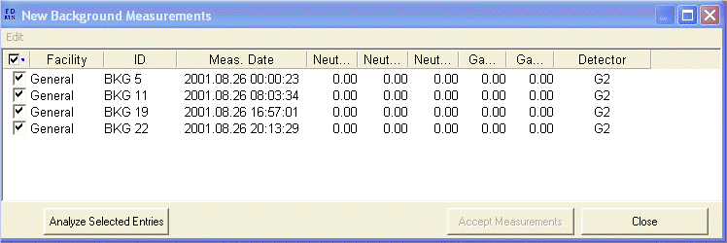

**Figure 10. The FDMS Import Background Measurements Dialog**

Figure 11 shows the result of pressing the “Analyze Selected Entries” button. Each of the four background measurements has been computed, and the numerical results are displayed in the channel columns. The alternating soft green background is the visual indicator of a successful event analysis.

Selecting “Accept Measurements” will retain any selected and analyzed background measurements in FDMS to be used in the next import processing steps.

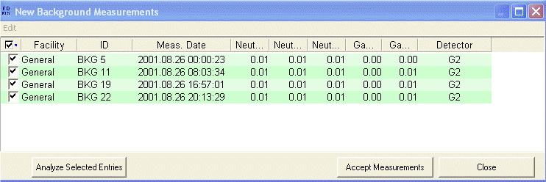

**Figure 11. The Background Dialog with Four Successfully Analyzed Background Measurements**

### Importing New Measurement Events

After Background event processing, the “New Measurement Events” table is displayed (see Figure 12). This table shows each channel event exported from RAD, one event per row. The cells or fields with a blue background represent data that can be edited by the user or that *must* be specified by the user. Note that the Measurement Date column is not editable. The measurement times and dates come from the original event data and cannot be changed.

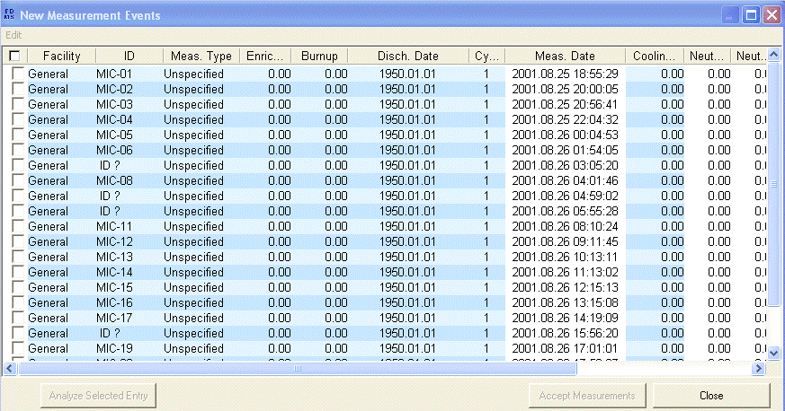

**Figure 12. The FDMS Import New Measurements Dialog**

For data editing, Figure 13 shows a cycle # being selected using the cycle # combo box in the cell. The value is about to be changed to 3 for the selected events. Notice that three events have been selected for analysis, using the checkbox in column one.

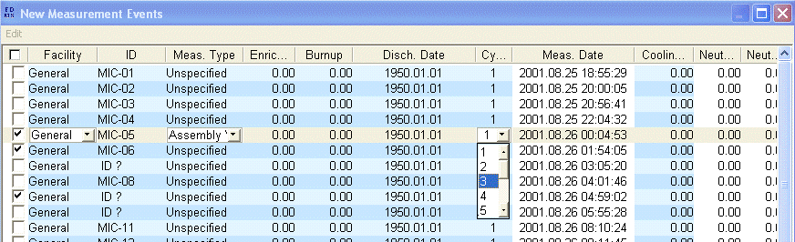

**Figure 13. The New Measurements Dialog with a Cycle # Selection in Progress**

Figure 14 shows the visual indicators for incomplete data. The “Analyze Selected Entries” button was pressed in Figure 15, but no analyses were successful, all due to incompletely specified information.

1. ID MIC-O5 is an Assembly Verification measurement. Both Enrichment and Burnup are required for that measurement type to be successfully analyzed.
2. ID MIC-O6 does not have a measurement type specified, nor has the initial default value for the Discharge Date been changed.
3. ID “?” does not have an ID specified. Plus, as with MIC-06, it is missing the measurement type and discharge date.

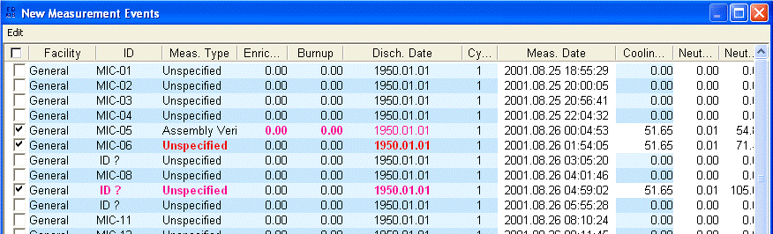

**Figure 14. The New Measurements Dialog with Required Event Data Highlights**

Figure 15 shows how a cooling time can be entered; the discharge date will be modified accordingly.

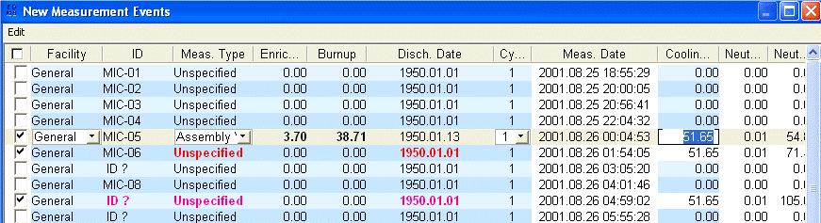

**Figure 15. The New Measurements Dialog with Cooling Time Editing**

Figure 16 shows the successful result of an analysis after the missing cooling time/discharge date has been entered. The entire row is now green. The ID is displayed in bold text. This measurement can now be accepted into FDMS. Note that the cycle number is red, which is a secondary indicator that the number was not changed but may be desirable to change.

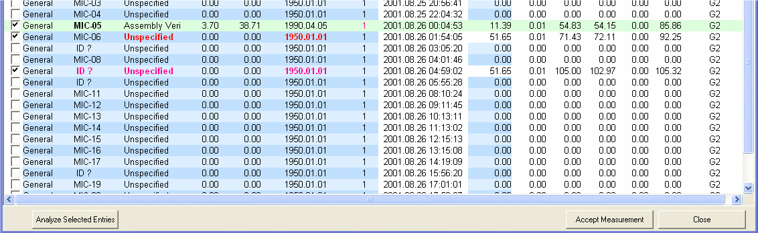

**Figure 16. The New Measurements Dialog with a Successful Assembly Verification Analysis**

Figure 17 shows the editing of the missing ID. The other required values have already been updated, and the changed values are still highlighted after editing, as seen in Figure 18. The analysis of the MIC-06 and MIC-09 events will now succeed because all of the required data have been entered. Pressing the “Analyze Selected Entries” button again results in three successful measurements that are ready to be accepted into FDMS (see Figure 19).

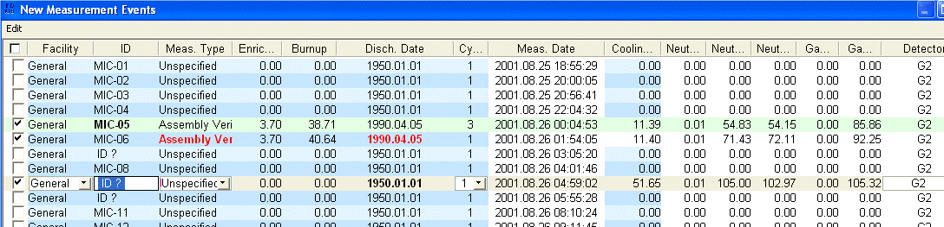

**Figure 17. The New Measurements Dialog with ID Editing**

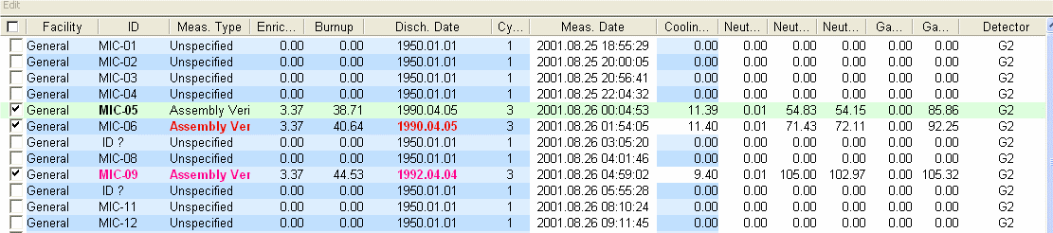

**Figure 18. The New Measurements Dialog with ID Editing Completed**

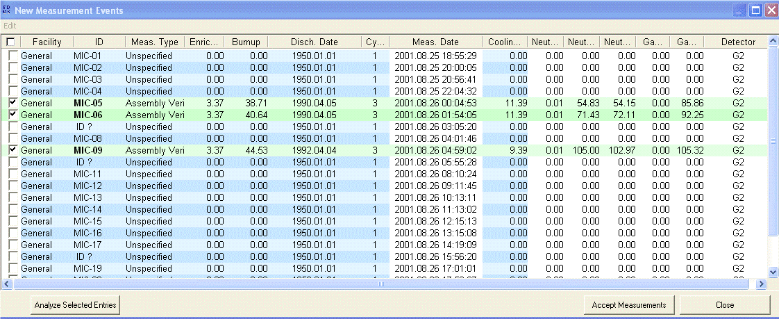

**Figure 19. The New Measurements Dialog Showing Three Successful Assembly Verification Analyses**

Here, the “Accept Measurements” button can be pressed, and the three valid measurements will be retained in FDMS. The next step is to review the newly imported and analyzed measurements using the existing FDMS graphs.

### Reviewing the Import Analysis Results

Activate the Assembly Verification graphs(see Figure 20, Figure 21, and Figure 22) to see the placement of the three newly analyzed events

|  |  |  |
| --- | --- | --- |
| **clip_image001**  **Figure 20. FDMS First Menu** | **clip_image001**  **Figure 21.  The Verification Menu** | **clip_image001**  **Figure 22. The Assembly Menu** |

The Neutron v. Burnup graph (see Figure 23) shows the three measurements fitting nicely in a range.

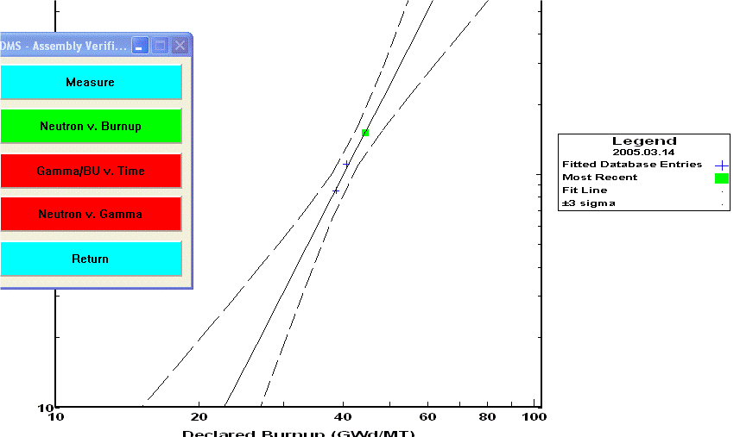

**Figure 23. The FDMS Neutron v. Burnup Graph**

Activate the FDMS measurement plan table (see Figure 24) to review, edit, and take the measurements again.

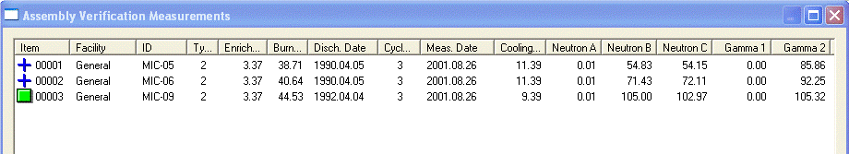

**Figure 24. The FDMS Assembly Measurements Dialog**

**Importing Existing Measurement Events**

Previous FDMS measurements may be analyzed, using new data and measurement times, when importing events from RAD. An imported event with an ID that matches an existing Assembly ID in the FDMS measurement plan will be presented in the Existing Measurements dialog.

Each existing measurement and the new event that will replace the existing measurement are shown in pairs in the dialog. The existing measurement is shown as a disabled row without a checkbox above the measurement event that will replace it. Similarly to the New Measurements dialog, the fields with the blue background may be modified for the analysis.

When the event details have been edited appropriately, select those measurements to be analyzed by checking the associated checkbox in the first column. Review the numerical results, and make any changes needed to produce a satisfactory analysis result.

To save the measurement data, select the “Accept Measurements” button. For each measurement that is to be replaced, FDMS requires an approval step. The new and existing values for each measurement are shown; select “Accept” to replace the measurement data, and select “Reject” to skip to the next measurement.

Figure 25, Figure 26, and Figure 27 show the steps outlined above.

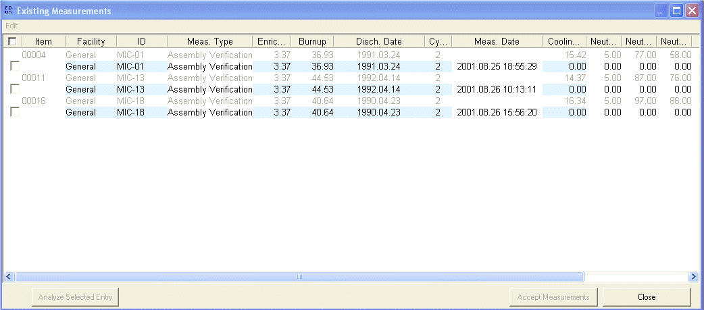

**Figure 25. The FDMS Import Existing Measurements Dialog**

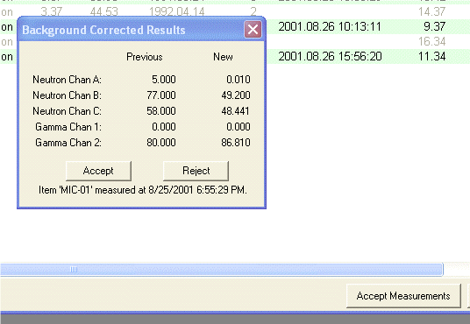

**Figure 26. Accepting Analysis Results for an Existing Measurement**

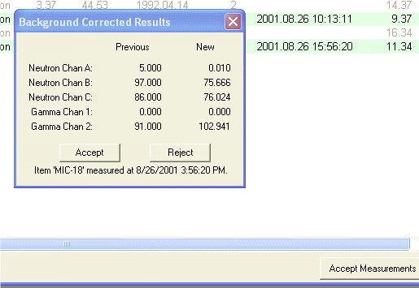

**Figure 27. Accepting Analysis Results for an Existing Measurement**

### Reviewing/Analyzing Imported Data

Again, the imported measurements analysis results can be reviewed in FDMS. Figure 28 and Figure 29 present screen shots of the MIC-## sample data as analyzed by FDMS.

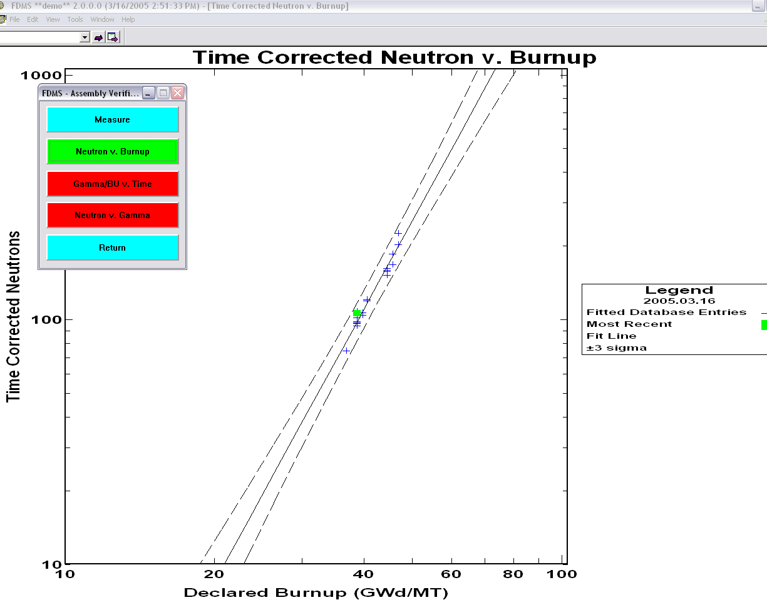

**Figure 28. Viewing the Imported Measurements in an FDMS Graph**

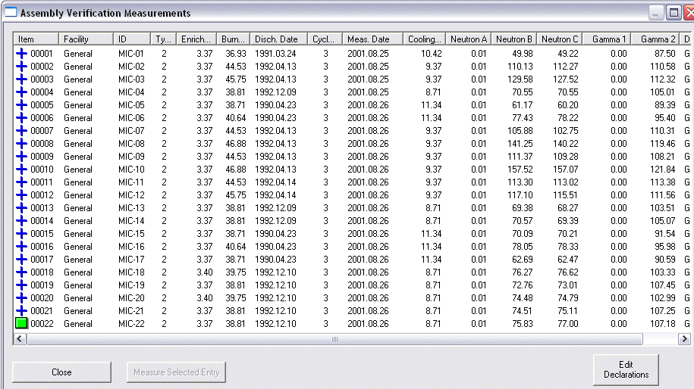

**Figure 29. The Same Events in the Assembly Verification Measurement Dialog**

### Moving Data from Excel to FDMS

The current FDMS table dialogs have limited editing capability. Microsoft Excel is the standard by which all other tabular editable dialogs are measured; thus, some support for pasting columns of data from Excel has been provided. By using the proper column titles, FDMS can match an attempt to paste a column of data into the New or Existing Measurement table dialogs.

Each FDMS database file is a comma-separated text file with a header row. The three files that comprise the FDMS database all use the same header row titles internally. By creating columns of data with a matching header cell title, FDMS can identify the column to paste data from Excel.

The procedure:

Copy the database or measurement plan file that is installed with FDMS. Open this copy in Excel; delete all data rows, leaving the header row intact. Use Excel to enter data in the column required. The fields that can be pasted from Excel into FDMS are Facility, Detector, ID, Measurement Type, Cycle #, Enrichment, Burnup, and Cooling Time. These data fields are required for editing when importing events into FDMS.

Figure 30 shows an Excel spreadsheet with columns of data for ID, cycle #, Enrichment, Burnup, and Cooling Time. The series of figures following shows the copy and paste operations from Excel to FDMS. First, select the column of data in the Excel spreadsheet, as shown in **Figure 32**. Then copy the selected data (Ctrl-C or Edit-Copy from the edit menu).The selected column data are copied to the Windows clipboard. Next, activate the FDMS import processing dialog, click anywhere on the dialog rows, and then use the dialog “Edit“ “Paste“ menu item to paste the data into the appropriate column. In the example, Cycle #’s are copied into the Cycle # column.

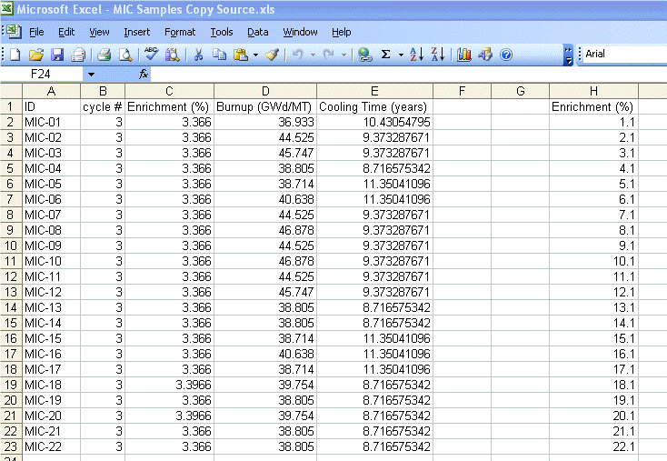

**Figure 30. Sample Excel Spreadsheet with FDMS Columnar Data**

|  |  |  |
| --- | --- | --- |
| clip_image001  **Figure 31. Selecting the “cycle #” Column** | clip_image001  **Figure 32. The Paste Menu Item on the FDMS Import New Measurements Dialog** | clip_image001  **Figure 33. Results in FDMS of Pasting the “Cycle #” Columnar Data** |

Figure 31, Figure 32, and Figure 33 show the process of copying from Excel, pasting into FDMS, and presenting the Results.

After a series of copy/paste operations, the fields for ID, Cycle #, Enrichment, Burnup, and Cooling Time (and this Discharge Date) have all been specified. The content was copied from columnar data in an Excel spreadsheet (see Figure 34). Now the analyses of these events can proceed.

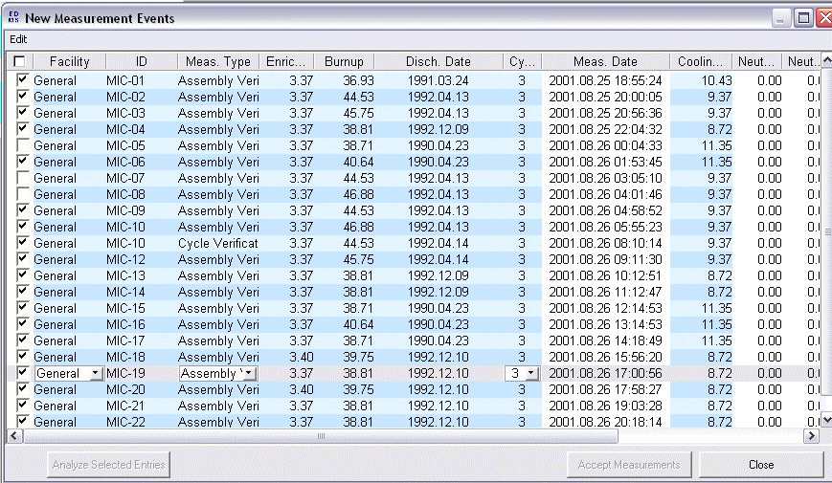

**Figure 34. New Measurement Dialog Data Fully Populated Using Excel as a Copy/Paste Data Source**

All of the selected measurements in this example have been successfully analyzed. When the “Accept Measurements” button is pressed, each such measurement will be saved into FDMS (see Figure 35).

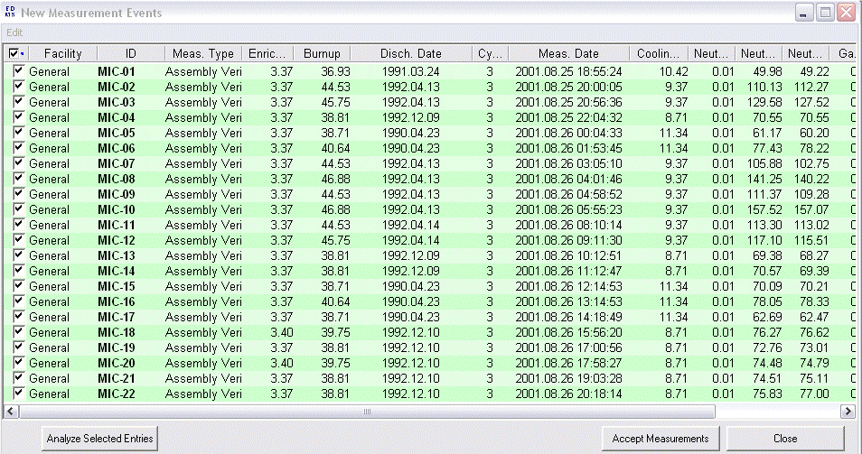

**Figure 35. New Measurement Dialog Data with Completed Event Analyses**

## Advanced FDMS Functions (Attended and Unattended)

### Changing Measurement and Analysis Parameters from the Menu

Seven configuration parameters, five measurement parameters and two post-measurement parameters may be modified from the FDMS Edit menu. Note that only Delta Enrichment and Delta Cooling Time parameters are used by Unattended FDMS, whereas all 7 parameters are used by Attended FDMS. Changing a parameter this way sets the new value active in the FDMS application until FDMS is closed or shut down. The inspector has the option of saving the modified parameters permanently (see Figure 43. Final Dialog).

**Background Cycles**

Background Cycles (see Figure 36) sets the value of the **BGCYCLES** configuration parameter [see § “[Initialization (INI) File](#_Initialization_(INI)_File)”, for details of this configuration value.] To provide an initial list of values for the menu, use the **BGCYCLES\_CHOICE** configuration parameter. Supply a comma-delimited list of values, i.e., **BGCYCLES\_CHOICE**=1,2,3,5,10.

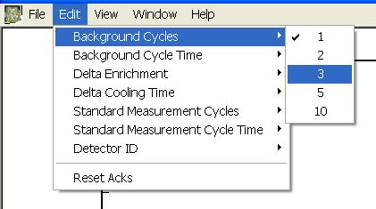

**Figure 36. Background Cycles**

**Background Cycle Time**

Background Cycle Time (see Figure 37) sets the value of the **BGCYCLETIME** configuration parameter [see § “[Initialization (INI) File](#_Initialization_(INI)_File)”, for details of this configuration value.] To provide an initial list of values for the menu, use the **BGCYCLETIME\_CHOICE** configuration parameter. Supply a comma-delimited list of values, i.e., **BGCYCLETIME\_CHOICE**=5,10,20,40,60.

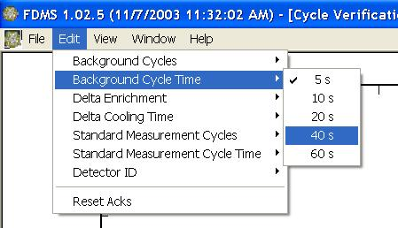

**Figure 37. Background Cycle Time**

**Standard Measurement Cycles**

Standard Measurement Cycles (see Figure 38) sets the value of the **CYCLES** configuration parameter [see § Initialization (INI) File, for details of this configuration value.] To provide an initial list of values for the menu, use the **CYCLES\_CHOICE** configuration parameter. Supply a comma-delimited list of values, i.e., **CYCLES\_CHOICE** =1,2,3,5,10.

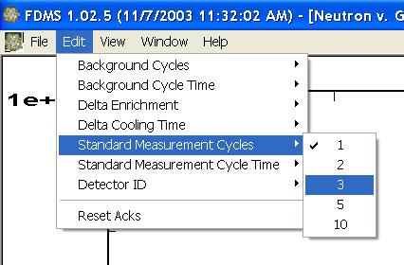

**Figure 38. Standard Measurement Cycles**

**Standard Measurement Cycle Time**

Standard Measurement Cycle Time (see Figure 39) sets the value of the **CYCLETIME** configuration parameter [see § Initialization (INI) File, for details of this configuration value.] To provide an initial list of values for the menu, use the **CYCLETIME\_CHOICE** configuration parameter. Supply a comma-delimited list of values, i.e., **CYCLETIME\_CHOICE**=5,10,20,40,60.

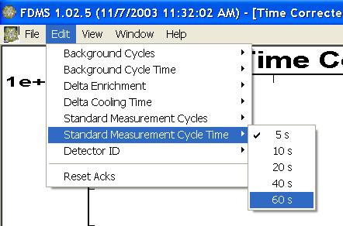

**Figure 39. Standard Measurement Cycle Time**

**Detector ID**

Detector ID (see Figure 40) sets the value of the **DETECTOR\_ ID** configuration parameter. This value is assigned to each new measurement and is stored in the measurement plan with the measurement results. To provide an initial list of values for the menu, use the **DETECTOR\_ID\_CHOICE** configuration parameter. Supply a comma-delimited list of values, i.e., **DETECTOR\_ID\_CHOICE**=FD01,FD02,FD03,FD04,FD05,FD06,FD07,FD08,FD09,FD10.

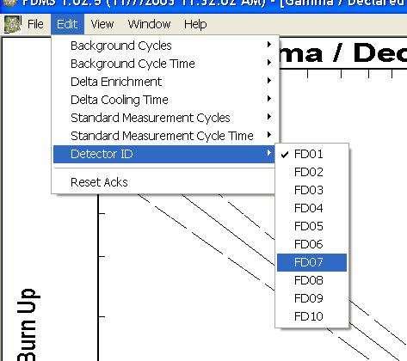

**Figure 40. Detector ID**

**Delta Enrichment**

Delta Enrichment (see Figure 41) sets the value of the **DELTA\_ENRICHMENT** configuration parameter [see § Initialization (INI) File, for details of this configuration value.] To provide an initial list of values for the menu, use the **DELTA\_ENRICHMENT\_CHOICE** configuration parameter. Supply a comma-delimited list of values, i.e., **DELTA\_ENRICHMENT\_CHOICE** =0.1,0.2,0.3,0.5,0.75,1.0.

**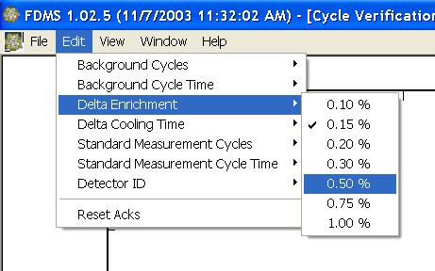**

**Figure 41. Delta Enrichment**

**Delta Cooling Time**

Delta Cooling Time (see Figure 42) sets the value of the **DELTA\_COOLINGTIME** configuration parameter [see § Initialization (INI) File, for details of this configuration value.] To provide an initial list of values for the menu, use the **DELTA\_ COOLINGTIME\_CHOICE** configuration parameter. Supply a comma-delimited list of values, i.e., **DELTA\_COOLINGTIME**\_ **CHOICE** =0.1, 0.2, 0.5, 1.0, 2.0, 5.0, 10.0.

**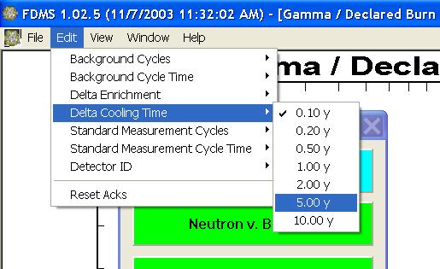**

**Figure 42. Delta Cooling Time**

**Permanently Save Configuration Parameters**

On program exit, any configuration parameter value changed during the FDMS session can be saved permanently, if desired. Simply say “Yes” to the final dialog, as shown in Figure 43, and the modified configuration parameters are saved to the FDMS configuration file (INI).

**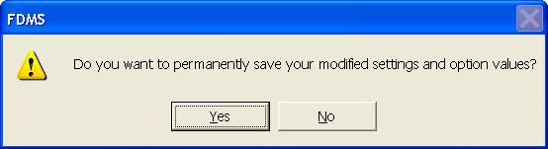**

**Figure 43. Final Dialog**

**Modifying Window Contents**

Plot displays and data windows can be manipulated to see different views of the data.

**Modifying Plots**

By clicking in the legend of a plot, each class of data point and fit can be removed and added to the plot. The software autoscales the plot, but the user can change the vertical scale by first placing the cursor to the right of the vertical axis and then using right and left mouse clicks in conjunction with the shift and Ctrl keys. The user can cycle through various combinations of plot grids by first placing the mouse in the bottom left-hand corner of the plot and then using either left or right mouse clicks.

**Modifying Data Windows**

Data file displays, such as the “New Measurement” window in the attended mode and the “New Measurement Event” window in the unattended mode, can be manipulated to view the data differently. The user can change the size of a data window and scroll horizontally and vertically to view all data contained in the window. The user can sort on any of the headings by clicking on these headings. For example, to view the data in ascending order of enrichment, left mouse click on the “enrichment” heading. To view in descending order, click on the heading a second time. Clicking on the “Item” heading can be used to return to the original order, as listed in the file. Column widths can be adjusted by clicking and dragging on the vertical sections between the individual headings.

# Installation

FDMS 2.1.1.0 is delivered as a component of the UNARM Integrated Review Software (IRS)9 package.

Install FDMS with Radiation Review by following the installation procedure outlined in the FDMS Checklist Procedure7 documentation for the IRS release9. The minimum IRS tool combination required is FDMS with RAD. The installation package provided on the UNARM Baseline 2 CD9 will install both RAD and FDMS together. Position Review, IAEA Neutron Coincidence Counting (INCC) software, and Digital Video Review are included, as optional applications.

After installation, find the folder where FDMS installed (normally C:\IRS\fdms, coupled with a specified facility folder <facility location>). Then open and look at these files. Open the INI file with Notepad and the \*.csv files with Excel. Make backups of the INI, DB, and MP files.

The FDMS files delivered in the UNARM IRS package are shown here.

|  |  |
| --- | --- |
| Ref Manual for Instrumentation - FDMS.pdf | Reference manual |
| Checklist Procedure.pdf | Checklist procedure |
| Database.csv | DB file, located in the facility data folder <facility location>\data\FDMS |
| Measurementplan.csv | MP file, located in the facility data folder <facility location>\data\FDMS |
| Measurements.csv | M file, located in the facility data folder <facility location>\data\FDMS |
| Fdms.exe | Executable that 1) communicates with a miniGRAND, and 2) integrates with Radiation Review (IRS); located in C:\irs\FDMS. |
| FDMS.ini | Primary configuration file, located in C:\irs\FDMS |
| ApplicationSettings.ini, ULAYR.ini | Secondary configuration files, located in the facility config folder <facility location>\config\FDMS |
| Fdmsdll.dll | FDMS DLL required to execute the FDMS software; located in C:\irs\FDMS. |
| Dforrt.dll | Fortran DLL required to execute the FDMS software located in C:\irs\FDMS. |

# References

1. J. Longo et al., *Fork Detector Measurement Software (Version 2.1.1.0)* LA-CC-03-02 (Feb. 24, 2010)*, packaged within* Integrated Review Software, LA-CC-10-095 (July 8, 2012).
2. J. Lestone, J. Longo, *Fork Detector Measurement Software User Guide (Version 2.1.1.0),* Safeguards Science and Technology Group N-1, Los Alamos National Laboratory, LA-UR-05-9043 (December 1, 2005).
3. J. Longo, *Quick User Instructions for FDMS 2.0. A Description of the New Unattended Measurement Features of the Fork Detector Measurement System,* Safeguards Science and Technology Group N-1, Los Alamos National Laboratory (March 12, 2005).
4. J. Lestone, J. Longo, *Fork Detector Measurement System (FDMS), Quick User Instructions for the Second Field Testable Version of the Software (Version 1.02),* Safeguards Science and Technology Group NIS-5, Los Alamos National Laboratory (November 7, 2003).
5. S. Klosterbuer, *Radiation* *Review User Manual,* Safeguards Science and Technology Group N-1, Los Alamos National Laboratory report LA-UR-99-1965 (December 1, 2004).
6. S. Klosterbuer, H. Nordquist, *Integrated Review Software Installation Manual,* Safeguards Science and Technology Group N-1, Los Alamos National Laboratory report LA-UR-04-8626 (February 25, 2005).
7. J. Longo, *Checklist Procedure for Instrumentation – Fork Detector Measurement System Software*, Safeguards Science and Technology Group NEN-1, Los Alamos National Laboratory report LA-UR-13-20590, (Jan. 23, 2013).
8. D. Pelowitz, P. Moore, T. Wenz, J. Longo, W. Hansen, *Multi-Instrument Collect User’s Manual*,Safeguards Science and Technology Group NEN-1, Los Alamos National Laboratory report LA-UR-13-20425 (July 8, 2012).
9. J. Longo, et al., *Unattended and Remote Monitoring Software Baseline 2 Revision 1*,Safeguards Science and Technology Group NEN-1, Los Alamos National Laboratory LA-CC 10-095, (Jul. 8, 2012).
10. J. Longo, *B2R1 Version Description Document, Revision 18*, Safeguards Science and Technology Group NEN-1, Los Alamos National Laboratory report LA-UR-13-20424, (Jan. 23, 2013).

1. If the INI-defined location and file names for the DB and MP files do not point to existing files, then the software will prompt the user for new location and file names for these files and update the INI file with this inputted information. [↑](#footnote-ref-1)